

American International University-Bangladesh (AIUB)
Department of Computer Science
Faculty of Science & Technology (FST)
PROJECT TITLE
BuyTrust: Your Marketplace for New & Pre-owned Items
Semester: Fall 25-26

Group: |  | Section:
SL | Student Name | Student ID
24 | KHOTHIK CHANDRA BHOWMICK | 23-53605-3
36 | MD. MURAD HASAN | 23-55559-3
34 | MESBAH UDDIN BHUIYAN | 23-55139-3
8 | SAMRAT ALAM | 22-49813-3
1 | MD ANWAR HOSSAIN | 12-218472-2

Table of Contents
Table of Contents
1. Project Proposal xx
1.1 Background to the Problem xx
1.2 Selection of Process Model xx
2. Software Requirements Specification (SRS) / PRD xx
2.1 Scopes and Features xx
2.2 User Story Table xx
2.3 Requirements Traceability Matrix xx
2.3.1 Functional Requirements xx
2.3.2 Non-Functional Requirements xx
3. Software Design xx
3.1 System Deisgn xx
3.2 UI Deisgn using Figma xx
4. Git Workflow xx
5. Software Testing xx
6. Conclusion xx

1. PROJECT PROPOSAL

  - Background to the Problem
In today’s digital era, online marketplaces have become an essential part of modern commerce, connecting buyers and sellers online in Bangladesh. However, many existing platforms either focus only on brand-new products or charge high commissions, making it difficult for individuals to sell pre-owned items. Additionally, issues such as lack of transparency, fake listings, and limited trust between buyers and sellers often discourage users from trading second-hand goods online.

BuyTrust: Your Marketplace for New & Pre-owned Items aims to solve these challenges by creating a secure, easy-to-use web platform where anyone can buy or sell both new and pre-owned products in one place. The project emphasizes trust, convenience, and fair pricing by including verified sellers, secure payment with protection, and clear communication channels between buyers and sellers. This approach not only promotes sustainable consumption by encouraging the reuse of items but also provides a reliable online space for small sellers and individuals to reach more customers efficiently. Online space for small sellers and individuals to reach more customers efficiently.

  - Selection of Process Model
For the development of BuyTrust: Your Marketplace for New & Pre-owned Items, the Agile SCRUM process model has been selected. SCRUM is a flexible, iterative, and user-focused software development approach that is highly suitable for modern web-based systems like online marketplaces.
At the current stage of the project, not all requirements can be considered fully fixed. Although the core functionalities such as user registration, product listing, secure payment, and delivery tracking are defined, additional refinements and improvements may arise during development. SCRUM effectively supports this situation by allowing requirements to be continuously updated and managed through a Product Backlog, ensuring adaptability without disrupting completed work.
SCRUM follows an incremental development process, where the system is developed in short time-boxed iterations known as Sprints. Each sprint typically includes requirement analysis, design, development, testing, and review activities. At the end of every sprint, a usable and tested software increment is produced. This enables the team to start development with the most important features and gradually enhance the system based on feedback and evaluation.
The SCRUM framework also emphasizes continuous feedback and regular review. After each sprint, sprint reviews and retrospectives help identify usability issues, technical improvements, and necessary changes. This early validation process reduces development risk and improves overall system quality.
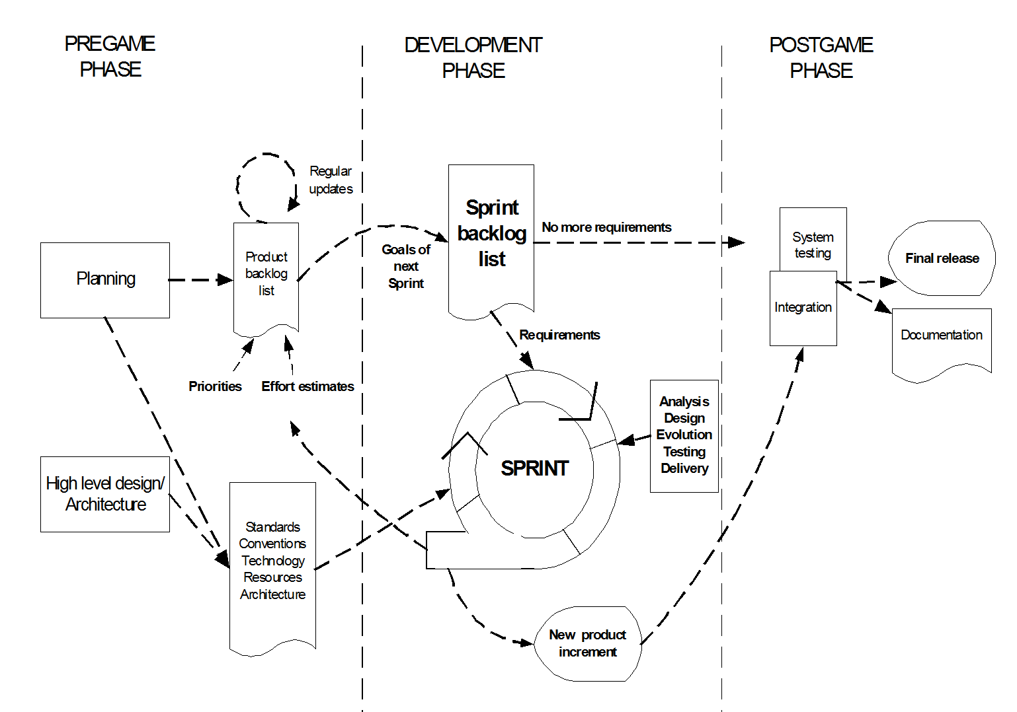
Another important reason for selecting SCRUM is the small team size and limited project duration (15–25 days). SCRUM encourages close collaboration, clear communication, and shared responsibility among team members. Regular meetings and defined roles help maintain transparency and ensure steady progress throughout the project lifecycle.
Compared to traditional process models such as Waterfall, which require fully finalized requirements at the beginning, SCRUM offers greater flexibility and responsiveness. This makes SCRUM the most appropriate choice for BuyTrust, ensuring timely delivery, better quality control, and a user-centric, reliable marketplace system.

2. SOFTWARE REQUIREMENTS SPECIFICATIONS (SRS) / PRODUCT REQUIREMENTS DOCUMENT (PRD)

2.1 Functional Requirements
Field | Value
Template Name | BuyTrust – Online Marketplace for New & Pre-Owned Items
Goals & Objectives | - Provide a secure, trustworthy online marketplace for buying/selling both new and pre-owned items.  - Allow users to list items with transparent pricing.  - Enable secure payment with buyer protection.  - Ensure verified sellers and reduced scam risk.  - Allow safe communication using built-in chat.  - Support small sellers with low commission.
Client Information | Internal University Project
Product Type | Web Application
Domain | Web2
Access Layers | User, Seller, Admin, Delivery Team, Agent
Design Required | Yes

Phase | Item No | Specification (Role) | Screen Definition | User Story | Acceptance Criteria
Feature: 1 – User Authentication |  | Auth Feature
phase 1 | 1 | [Buyer, Seller] User Registration | Email & Password, Name,  Phone Number field  Signup Button  Third Party SSO  Login button | As a user, I want to create an account so I can access the platform. | - The system should accept only valid and unregistered email addresses or display "Email already used"  - The password should be at least 8 characters long or display an invalid password message  -The re-password should match the password or display "Password does not match".  -The user type should be selected or display "Please select a user type"  - Clicking signup should store credentials and redirect to the dashboard.  - Login information should be sent to the user email.
phase 1 | 2 | [Buyer, Seller] Login | Email/Username & Password  Third Party SSO Login  Signup Button | As a user, I want to log in securely. | - Email should match the registered email in the database.  - Password should match the registered password in the database.  - The user should be redirected to the dashboard when the email and password match the database.  - The user should see the error "Email or password does not match!" when credentials do not match.  - Clicking signup should take the user to the signup page.  - Clicking forgot password should take the user to the forgot password page.
phase 1 | 3 | [User] Forgot Password | Email address  Verification Code  Confirm Button | As a user, I want to reset my password. | - Email should match the registered email in the database or show "No email found!".  - Pressing send code should show the "code sent!" message and the code should appear in the user info row.  - The new password should be at least 8 characters long and include one special character.  - Re-type password should match the new password.  - Clicking submit should show "password changed" if all information matches or indicate what is wrong.
phase 1 | 4 | [User] Profile Management | User Name  Profile picture  Phone number  Email  Address  Update Button | As a user, I want to update my information. | - The user should be able to change name, picture, phone, email, and address.  - Clicking update should save changes to the database.  - Updated information should show on the profile immediately.  - A success message should appear after update.
phase 1 | 5 | [Admin] Block/Unblock User | List of registered buyers and sellers  Block/Unblock button  Verify button | As an admin, I want to block/unblock users if necessary. | - The admin should see all registered buyers and sellers.  - Clicking block should prevent the user from logging in.  - Clicking unblock should allow the user to log in again.  - Clicking verify should mark the user as verified.  - Changes should save to the database immediately.
Feature: 2 – Product Management
phase 1 | 6 | [Seller] Add Product | Product Image  Name  Price  Details  Quantity  Add product button | As a seller, I want to list new products. | - All fields should be filled or the system should show an error message.  - An image should be uploaded.  - Price should be a valid number.  - Quantity should be a positive number.  - Clicking add product should save the product to the database.  - The new product should appear in the seller's product list.
phase 1 | 7 | [Seller] Edit Product | Product Image  Name  Price  Details  Quantity  Edit product button | As a seller, I want to update product info. | - The seller should be able to change image, name, price, details, and quantity.  - All fields should be filled or the system should show an error.  - Clicking edit product should save changes to the database.  - The updated product should show the new information immediately.
phase 1 | 8 | [Seller] Delete Product | Product List with name, price, details, quantity  Delete button  Confirm Button | As a seller, I want to remove products. | - Clicking delete should show a confirmation popup.  - Clicking confirm should remove the product from the database.  - The product should disappear from the seller's list.  - The product should no longer be visible to buyers.
phase 1 | 9 | [Buyer] Browse Products | Product List with Product name, price & image  Add to cart  Buy button | As a buyer, I want to view products. | - All products should show with name, price, and image.  - Products should load in pages with navigation.  - Clicking add to cart should add the item to the cart.  - Clicking buy should go to the checkout page.
phase 1 | 10 | [Buyer] Products Details | Product name, price & image & details  Related products  Add to cart button  Buy button | As a buyer, I want see product details | - The page should show product name, price, image, and full details.  - Related products should display at the bottom.  - Clicking add to cart should add the item to the cart.  - Clicking buy should go to checkout with this product.
phase 1 | 11 | [Buyer] Product Search | Search text box | As a buyer, I want to search product with text easily. | - Typing in the search box should show matching products.  - Search should work on product name and details.  - Results should update as the user types.  - If there are no results, the system should show the message "No products found".
phase 2 | 12 | [Buyer] Product Filter | Categories, Company, Model, Min Price, Max Price, New or Old product Dropdown list | As a buyer, I want to filter items with some criterias. | - The buyer should be able to select category, company, model, and condition.  - The buyer should be able to set a minimum and maximum price range.  - Applying the filter should show only matching products.  - The clear filter button should reset all selections.
Feature: 3 – Communication
phase 2 | 13 | [Buyer or Seller] Chat Messaging | Message box  Old messages area  Send button | As a user, I want to chat with sellers or buyers. | - The user should be able to type a message in the message box.  - Clicking send should deliver the message instantly.  - Old messages should show in the conversation history.  - New messages should appear without refreshing the page.
phase 2 | 14 | [Buyer] Feedback & Complaint Handling | Complaint Type dropdown  Complaint textbox  Submit button | As a user, I want to complain about issues that I faced. | - The user should select a complaint type from the dropdown.  - The user should write the complaint in the textbox.  - Both fields should be filled or the system should show an error.  - Clicking submit should save the complaint to the database.  - A success message should show "Complaint submitted".
phase 2 | 15 | [Agent] Feedback & Complaint Handling | List of complaint submitted  Reply textbox  Reply button  Resolve button | As an agent, I want to respond to feedback. | - The agent should see all submitted complaints.  - The agent should write a reply in the textbox.  - Clicking reply should send the response to the user.  - Clicking resolve should mark the complaint as resolved.  - Resolved complaints should move to the resolved list.
Feature: 4 – Cart & Checkout
phase 1 | 16 | [Buyer] Add to Cart | Product name, price & image  Quantity selector  Add to cart button | As a buyer, I want to add items to my cart. | - The buyer should select quantity before adding.  - Clicking add to cart should save the item with the selected quantity.  - The item should appear in the cart immediately.  - The cart icon should show the total item count.
phase 1 | 17 | [Buyer] Remove from Cart | Cart items list with product name, price, quantity & image  Quantity adjuster  Remove button | As a buyer, I want to remove items. | - The cart should show all added items with details.  - The buyer should be able to increase or decrease quantity.  - Clicking remove should delete the item from the cart.  - The cart total should update automatically.  - If the cart is empty, the system should show the message "Your cart is empty".
phase 1 | 18 | [Buyer] Checkout | Cart summary  Shipping address  Payment method selector  Order total with commission  Place order button | As a buyer, I want to complete my purchase. | - The cart summary should show all items and prices.  - Shipping address should be filled or the system should show an error.  - A payment method should be selected.  - Total should show subtotal plus 10% commission.  - Clicking place order should create the order and go to payment.
phase 1 | 19 | [System] Apply 10% Commission | Order calculation engine  Subtotal display  Commission (10%) display  Total amount display | As system, I must deduct commission. | - The system should calculate 10% commission automatically.  - Subtotal should show the sum of product prices.  - Commission should show as a separate line item.  - Total should show subtotal plus commission.  - Commission should be deducted before payment to the seller.
Feature: 5 – Payment System
phase 1 | 20 | [Buyer] Secure Payment Processing | Payment method options (Card/Mobile Banking/Wallet)  Pay now button | As a buyer, I want secure payment. | - The buyer should select card, mobile banking, or wallet.  - The payment gateway should open in a secure window.  - Clicking pay now should process the payment.  - On success, the system should show a confirmation message.  - On failure, the system should show an error and a retry option.
phase 1 | 21 | [System] Payment Status Update | Order ID  Payment status indicator  Transaction reference  Timestamp | As system, I must update payment status. | - The system should update status to Paid or Failed.  - The order should show the transaction reference number.  - A timestamp should record the payment time.  - The buyer and seller should get a status notification.  - Status should save to the database immediately.
Feature: 6 – Delivery System
phase 1 | 22 | [Admin] Review Delivery Status | Order list with delivery status  Delivery team  Delivery address | As admin, I want to review current delivery status of all products. | - The admin should see all orders with delivery status.  - Each order should show the assigned delivery team.  - The delivery address should display for each order.  - Status should show Pending, Out for Delivery, or Delivered.  - The admin should be able to filter by status.
phase 1 | 23 | [Delivery Team] Update Delivery Status | Assigned order list  Order details  Status dropdown (Pending/Out for Delivery/Delivered)  Update status button | As delivery staff, I want to update status. | - The delivery team should see their assigned orders.  - Order details should show customer address and items.  - The team should select a new status from the dropdown.  - Clicking update should save the status to the database.  - The buyer and seller should get a status notification.
phase 1 | 24 | [Buyer or Seller] View Delivery Status | Order tracking number  Delivery status timeline  Delivery team name & contact  Estimated delivery time | As a user, I want to see who is handling the delivery and current status. | - The user should enter a tracking number to view status.  - The timeline should show Pending, Out for Delivery, and Delivered.  - Delivery team name and contact should be displayed.  - Estimated delivery time should show on the page.  - The page should update when status changes.
Feature: 7 – Order & Reports
phase 2 | 25 | [Seller] View Sales Reports | Date range selector  Sales chart/graph  Total revenue display  Product-wise sales breakdown  Order count | As a seller, I want to see insights. | - The seller should select a start and end date.  - The chart should show sales over the selected time period.  - Total revenue should display at the top.  - The breakdown should show sales for each product.  - Order count should show total orders in the selected range.
phase 2 | 26 | [Admin] Order Management | All orders list with filters  Order details view  Status dropdown  Search & filter options  Update button | As admin, I want to manage all orders. | - The admin should see all orders from all users.  - The admin should be able to search by order ID or user.  - The admin should be able to filter by status or date.  - The admin should be able to view full order details.  - The admin should be able to change order status.  - Clicking update should save changes to the database.
Feature: 8 – Security & Verification
phase 2 | 27 | [System] Two-Factor Authentication (optional) | OTP input field  Resend OTP button  Timer display  Verify button | As system, I want secure login via OTP. | - The OTP should be sent to the user email or phone.  - The user should enter a 6-digit OTP code.  - The timer should show a 120 seconds countdown.  - Clicking resend should send a new OTP.  - Clicking verify should check the OTP and log in the user.  - If the OTP is wrong, the system should show the error "Invalid OTP".
phase 2 | 28 | [System] Fraud Detection Alerts | Alert notification panel  Flagged account list  Activity log  Risk level indicator  Review button | As system, I want to detect suspicious activity. | - The system should flag suspicious login attempts.  - The system should flag unusual purchase patterns.  - The alert panel should show all flagged activities.  - Risk level should show Low, Medium, or High.  - The activity log should show user actions.  - The admin clicking review should open the account investigation flow.

Non-Functional Requirements
Category | Item No | Specification | Requirements | Acceptance Criteria
Performance | 29 | Fast Homepage Loading | Homepage should load quickly | Homepage should load in 3 seconds on 4G
Performance | 30 | Fast API Responses | API calls should be quick | 90% of API calls should finish in <500ms
Reliability | 31 | System Availability | System should always work | System should maintain 99.5% uptime each month
Reliability | 32 | Quick Recovery | System restarts automatically | System should recover in less than 2 minutes
Scalability | 33 | Handle Many Users | Support large user numbers | System should handle 50k users at once
Security | 34 | Safe Passwords | Encrypt all passwords | Passwords should be stored in hashed format
Security | 35 | OTP Timeout | OTP should expire quickly | OTP should expire after 120 seconds
Usability | 36 | Consistent Design | All pages look the same | UI should use the same fonts, spacing, and buttons everywhere
Usability | 37 | Mobile Friendly | Works on phones | All pages should work on mobile devices
Maintainability | 38 | Organized Code | Code is easy to update | Code should be split into modules with comments
Maintainability | 39 | Data Backup | Backup important data | An auto-backup should run daily
Compatibility | 40 | Browser Support | Works in all browsers | System should support Chrome, Edge, Firefox, and Safari

3. SOFTWARE DESIGN
3.1 System Design:
3.1.1 Use Case Diagram

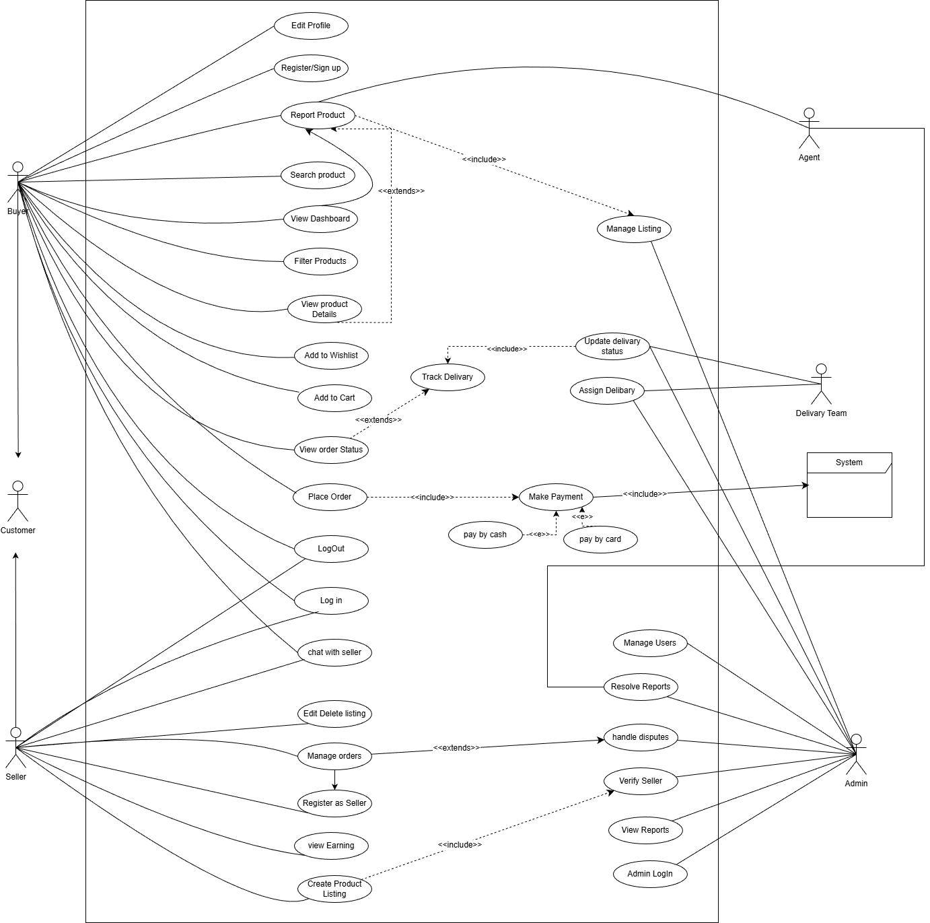

3.1.2 Activity Diagram
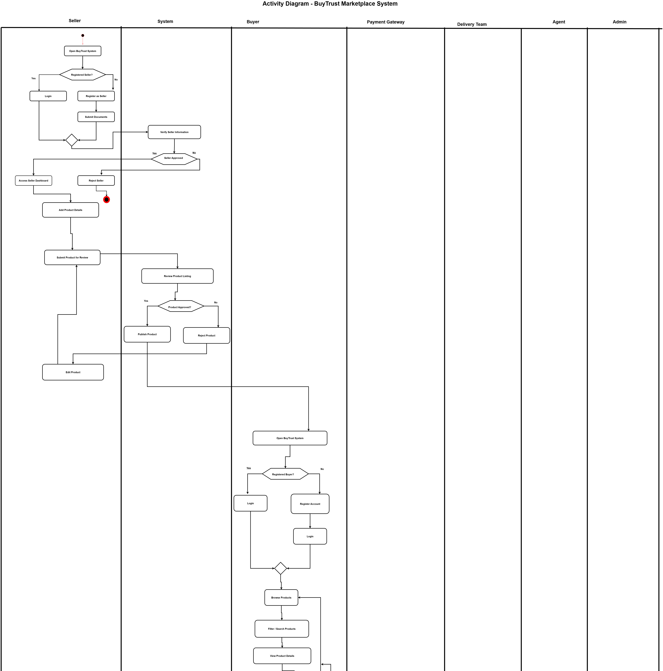

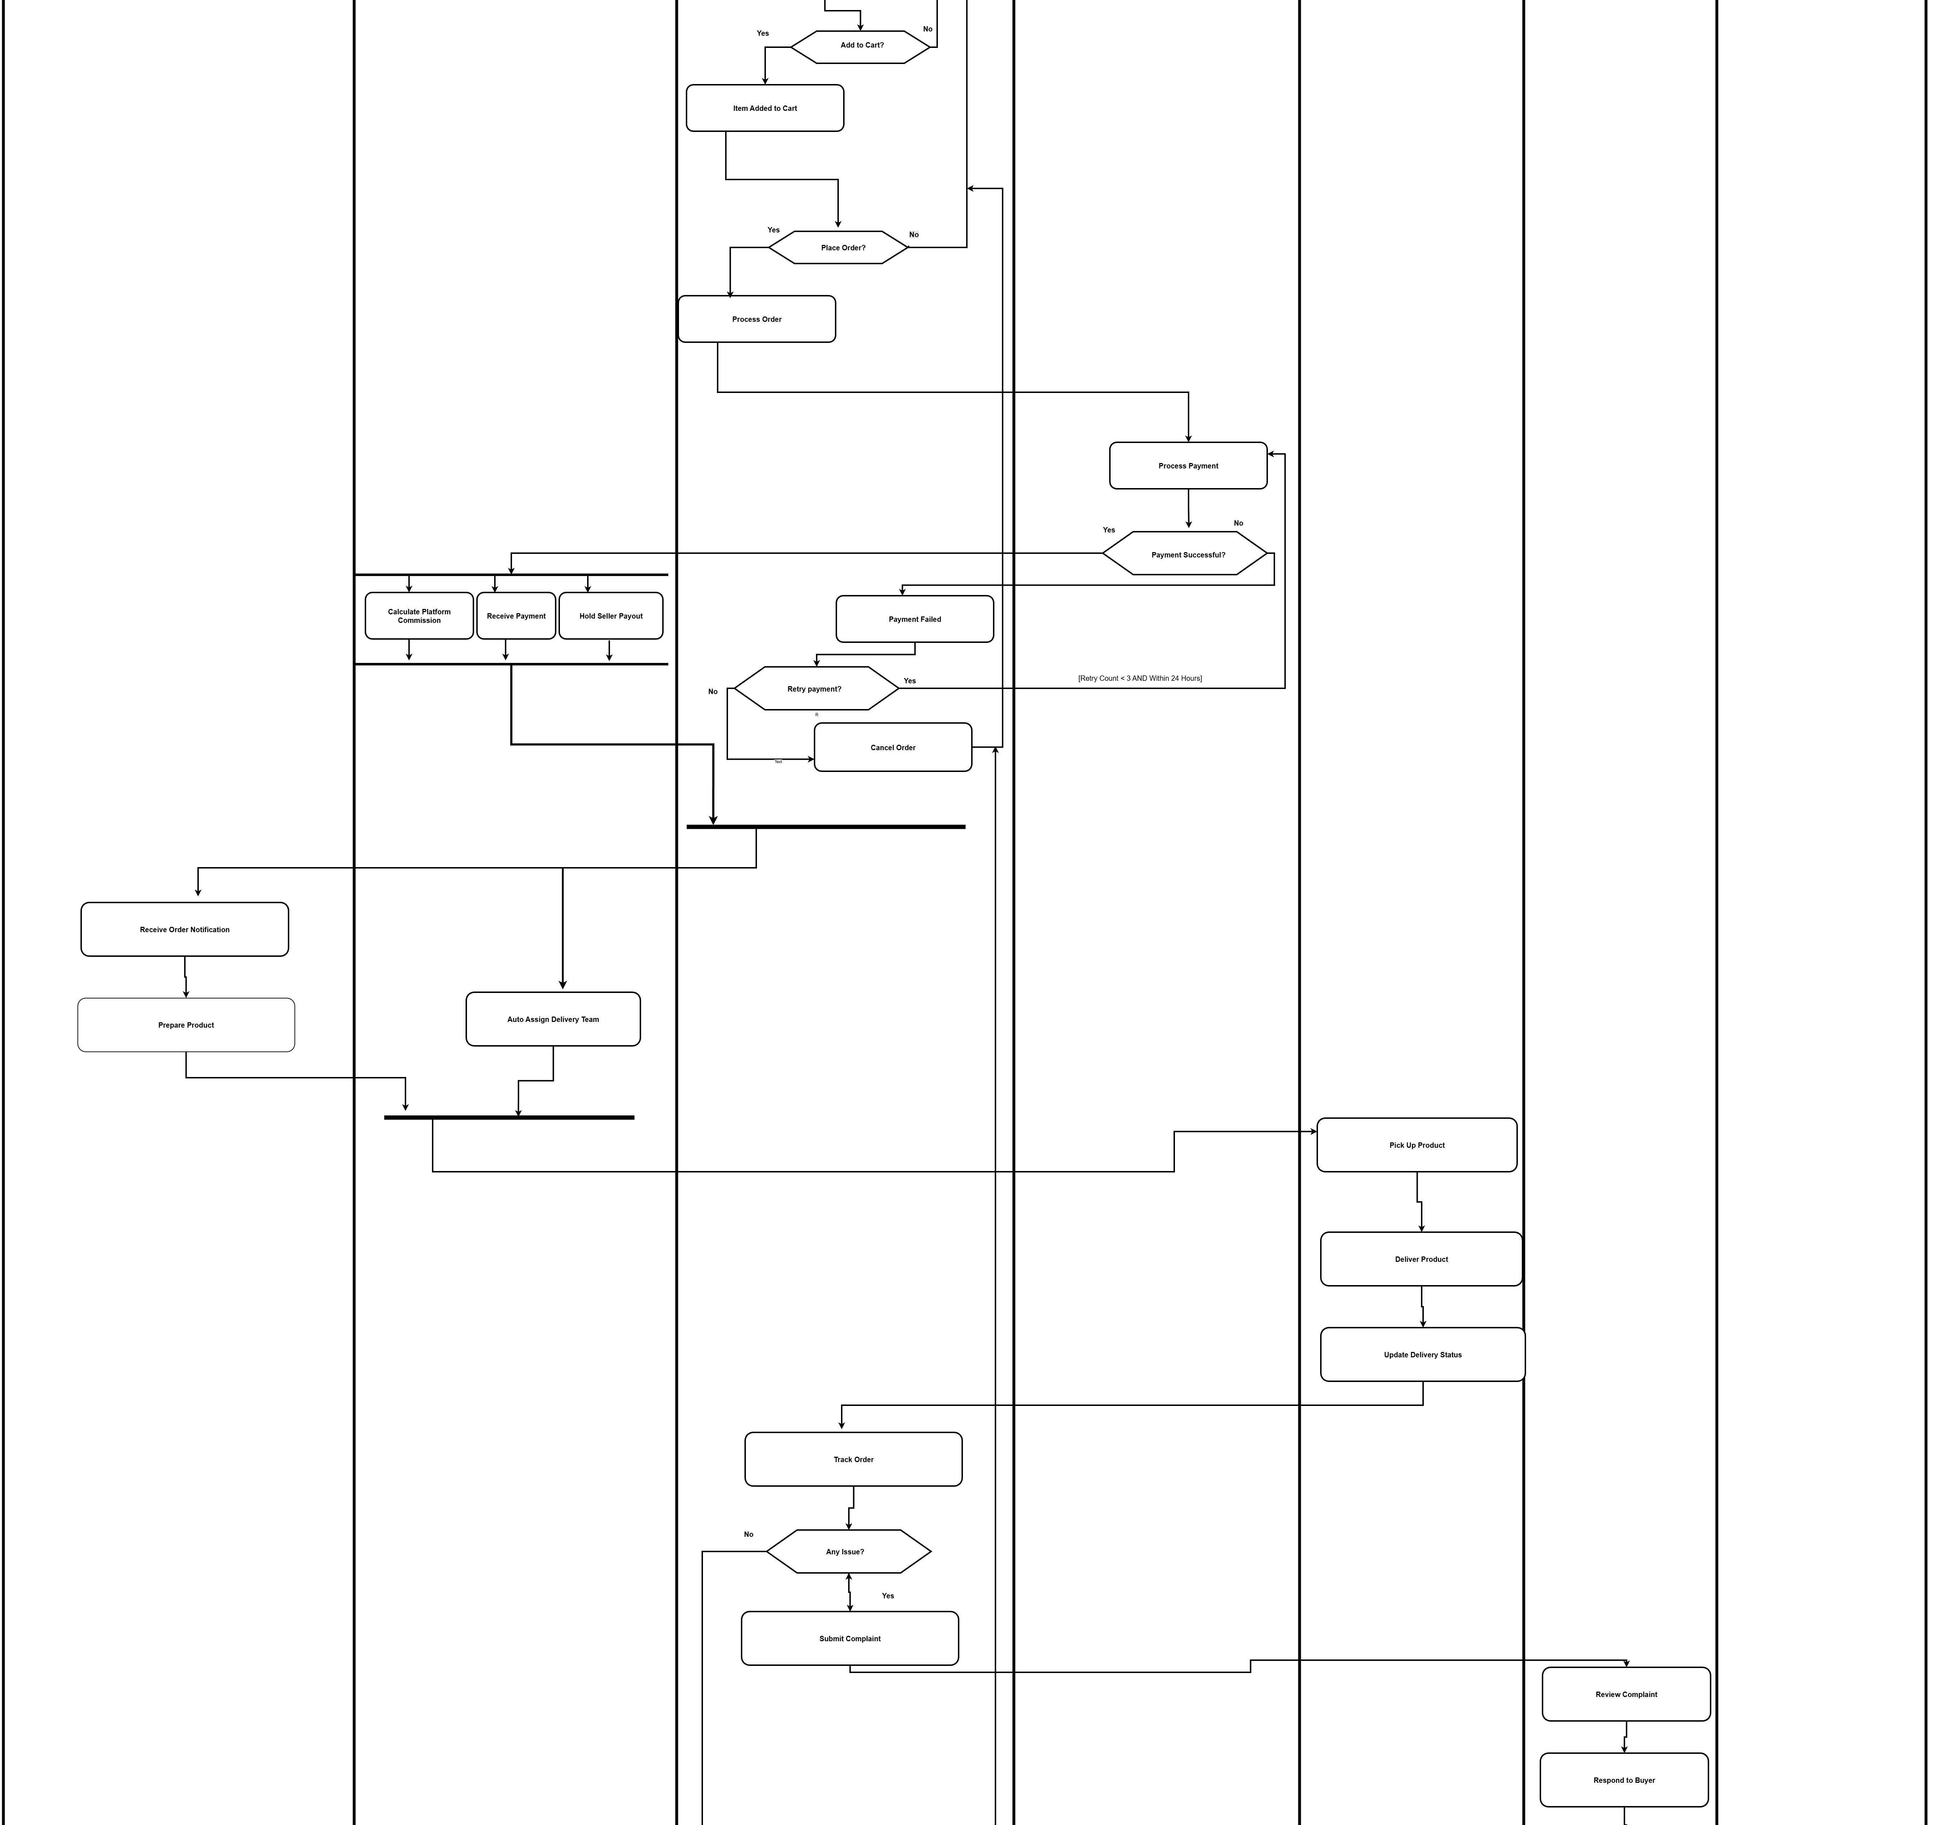

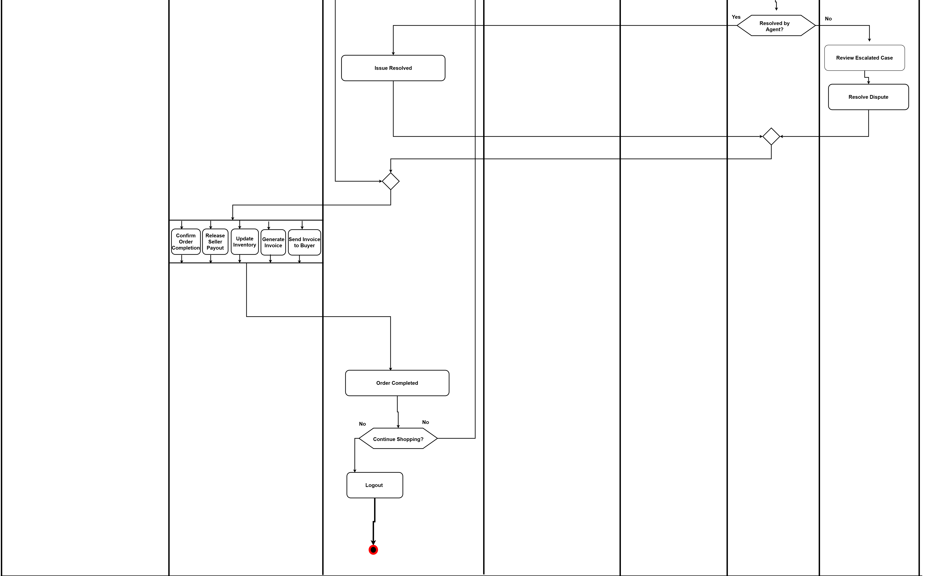

3.1.3 Class Diagram
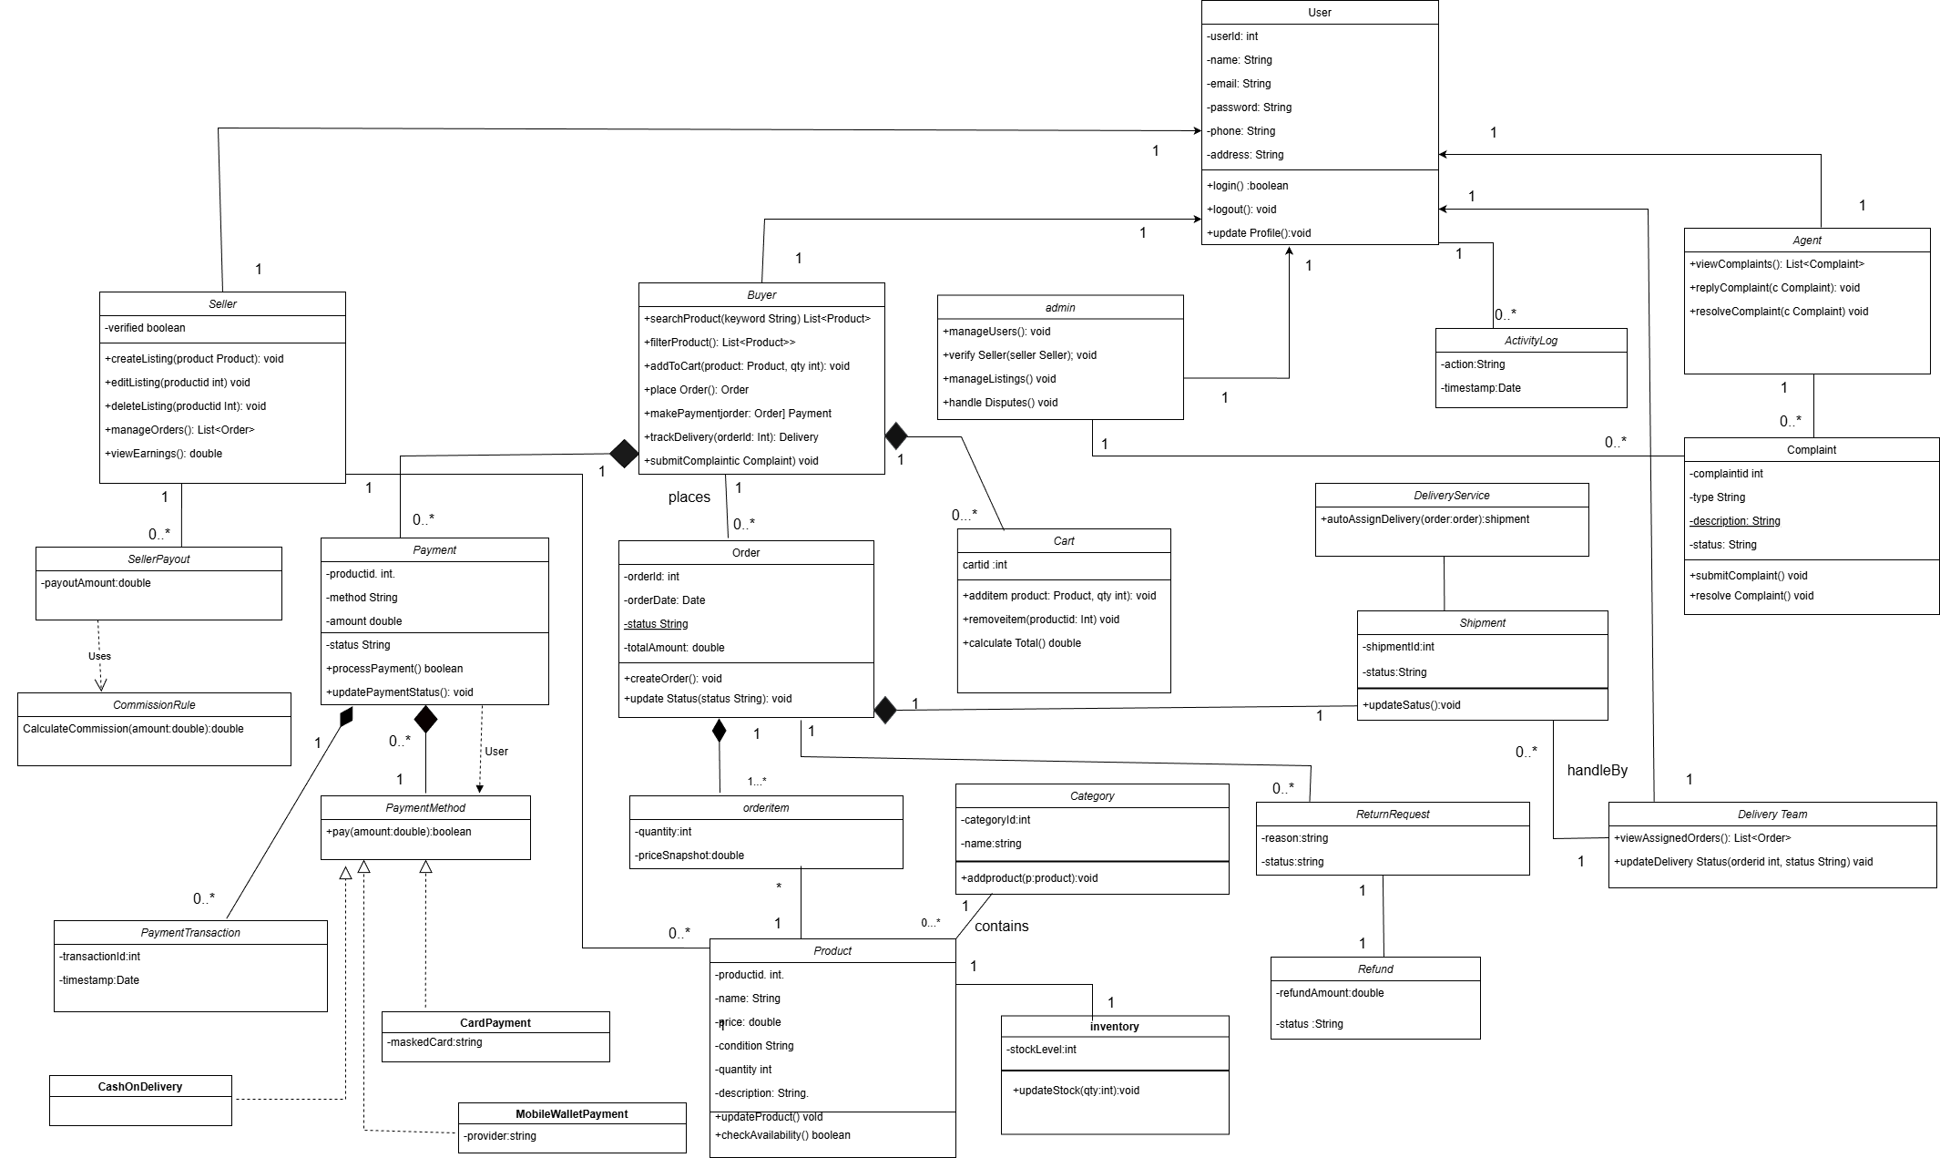
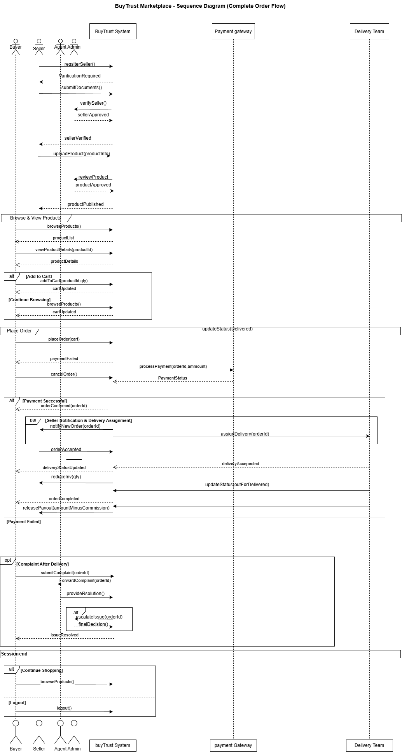
3.1.4 Sequence Diagram

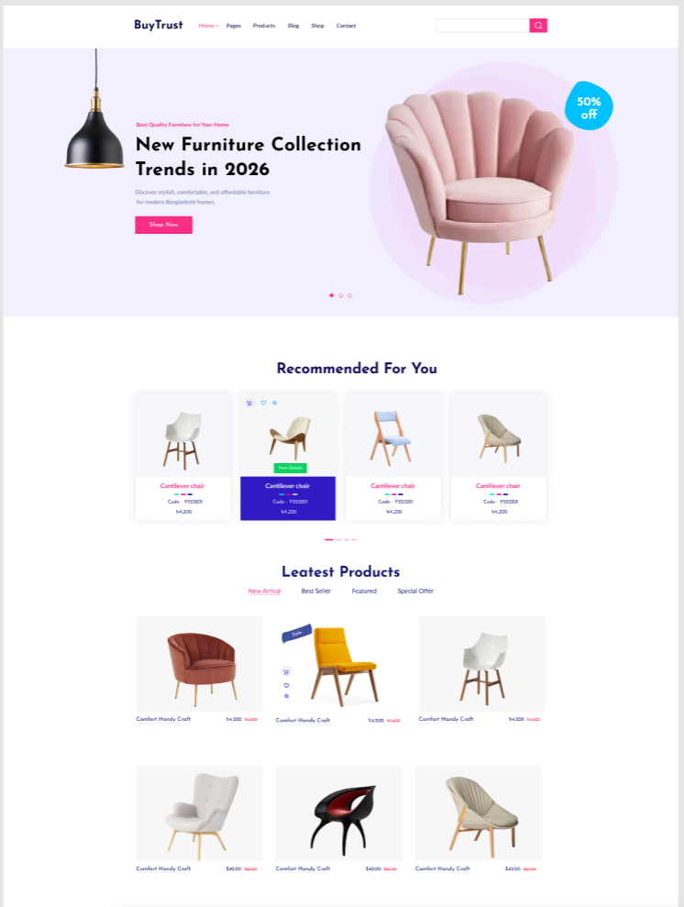
UI / Wireframe Design using Figma
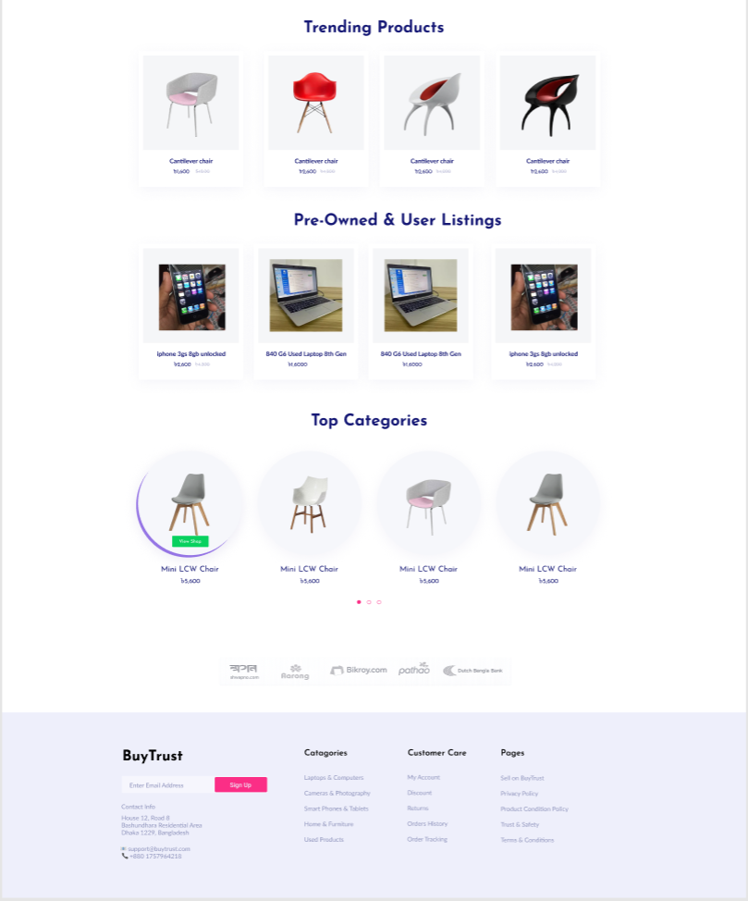
Fig: Home page
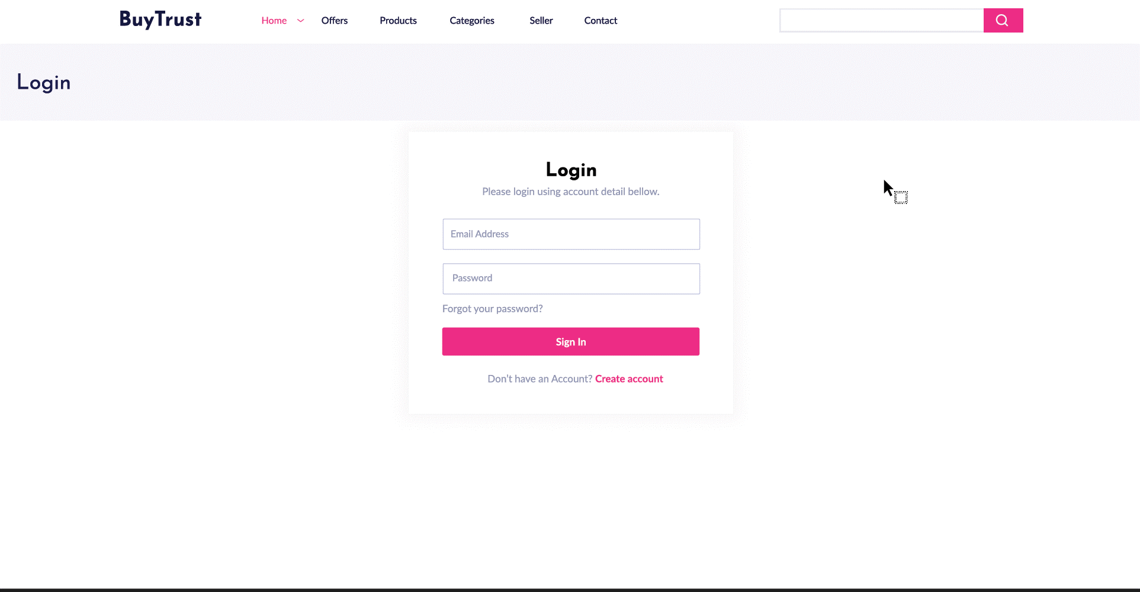
Fig:Login page
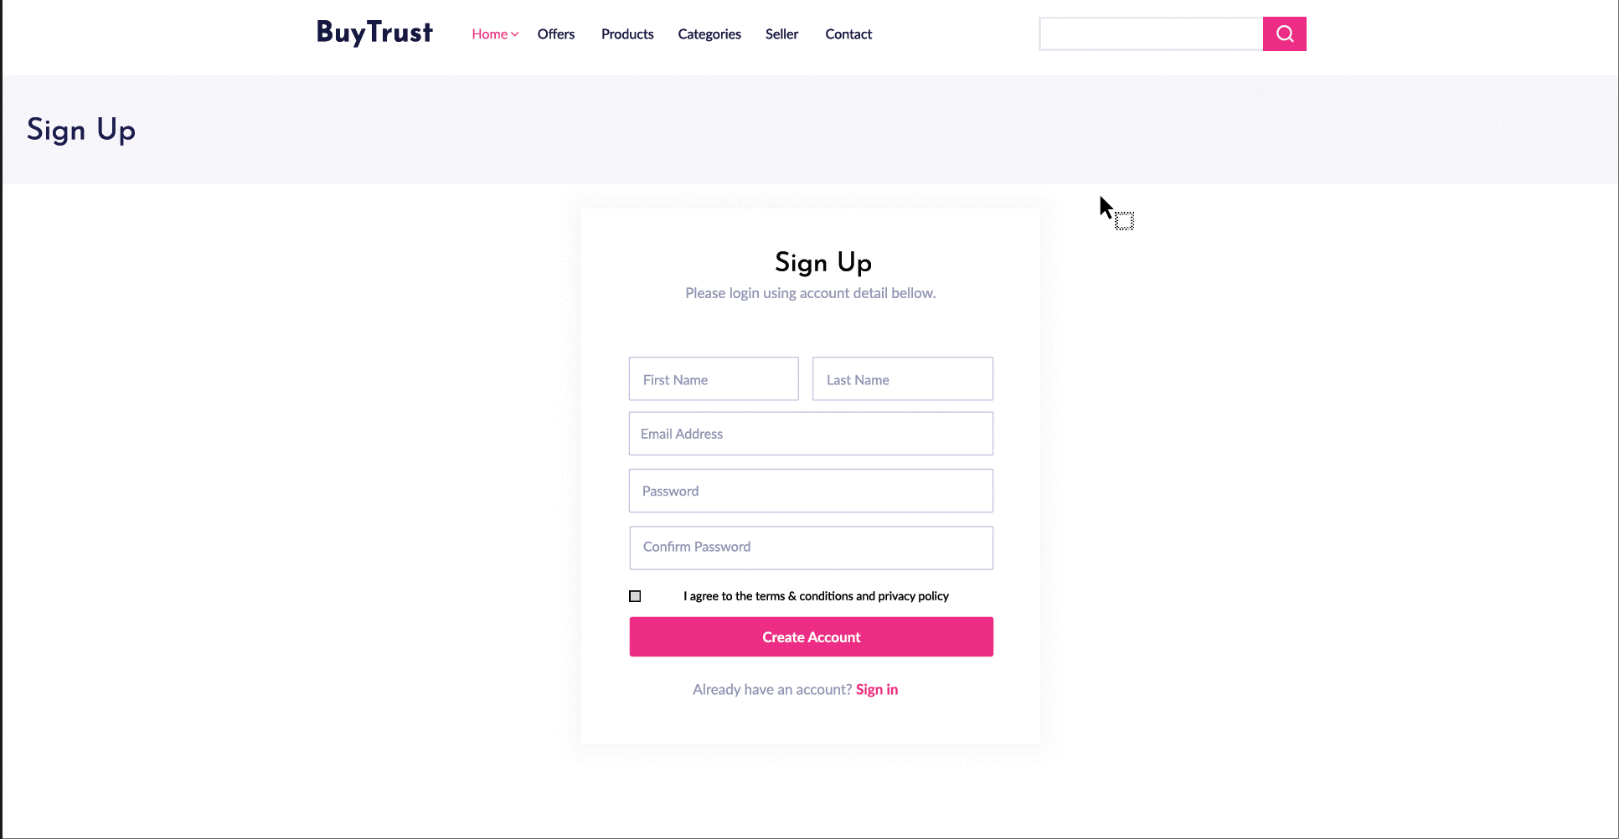
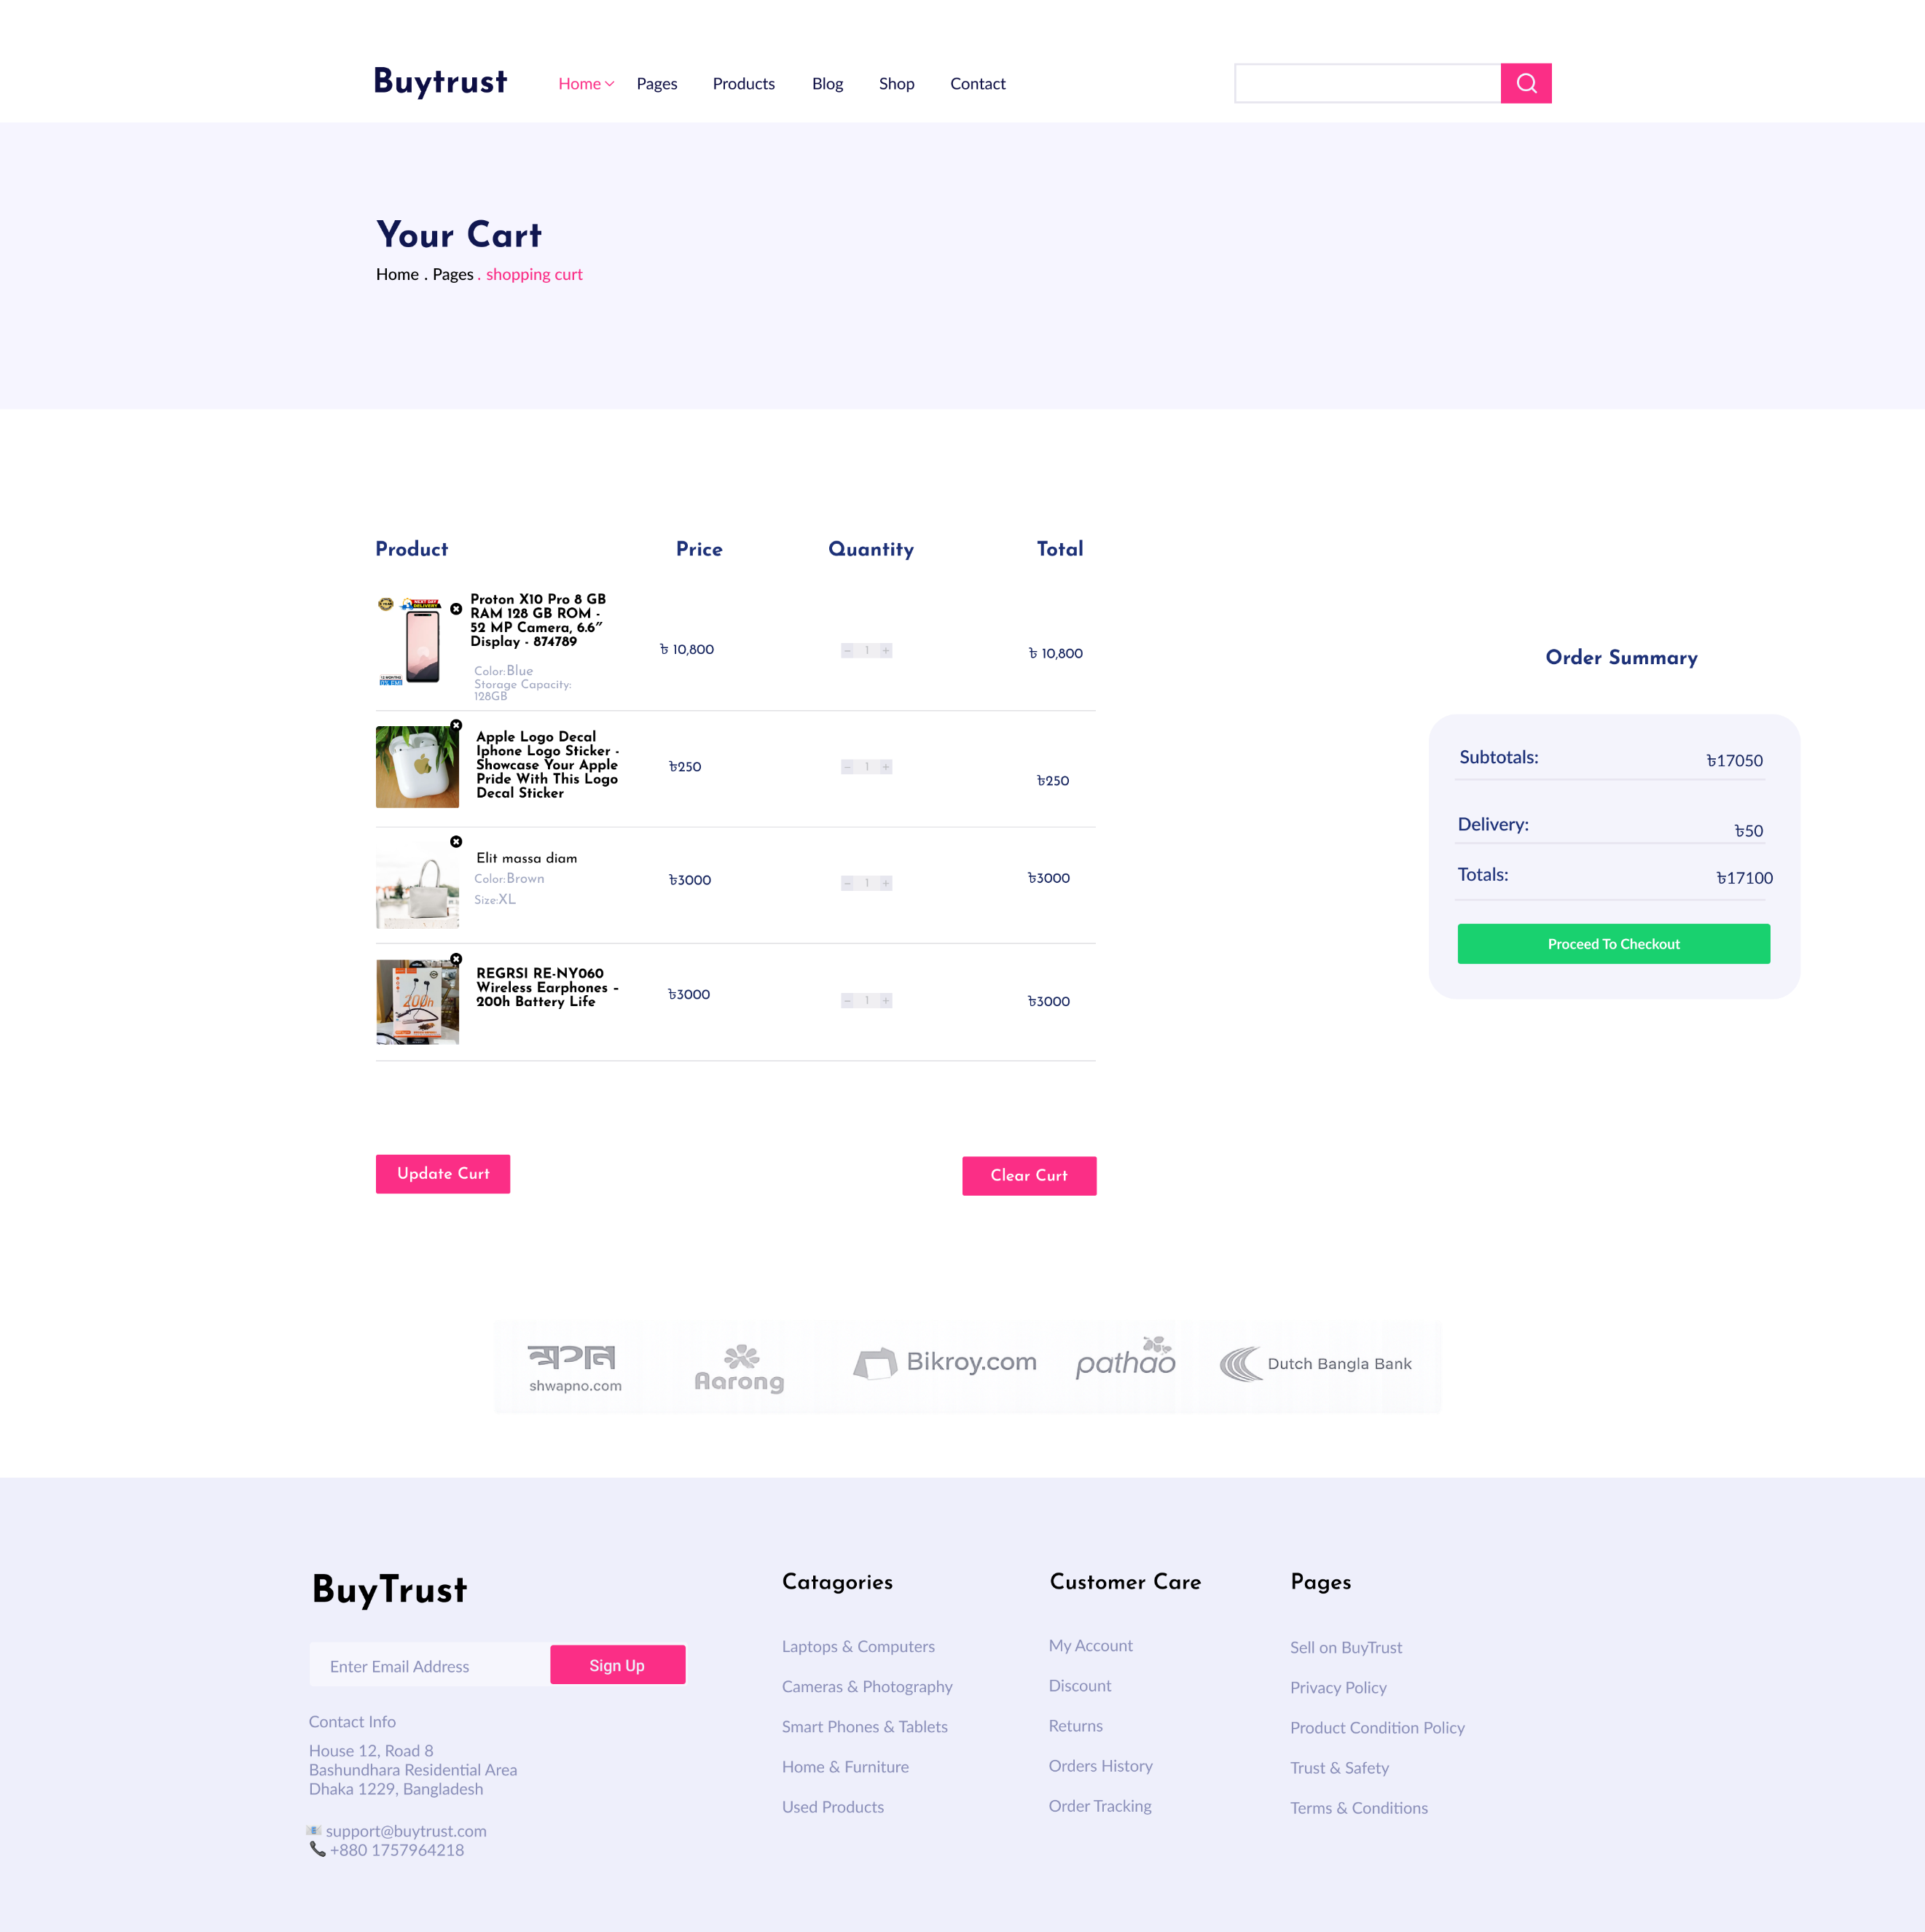
Fig: SignUp Page
Fig: Cart Page

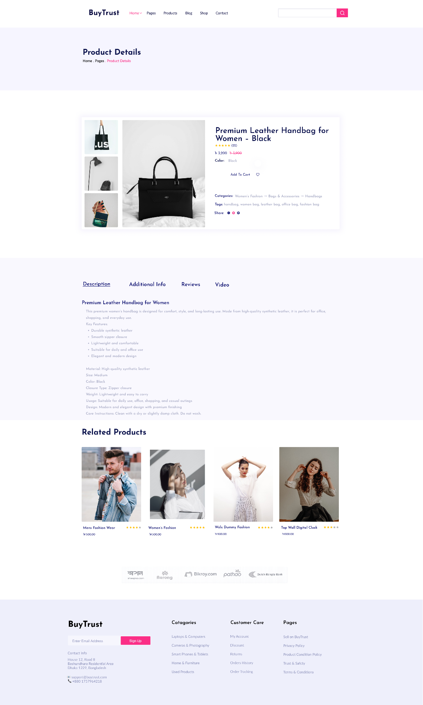
Fig:Product Page
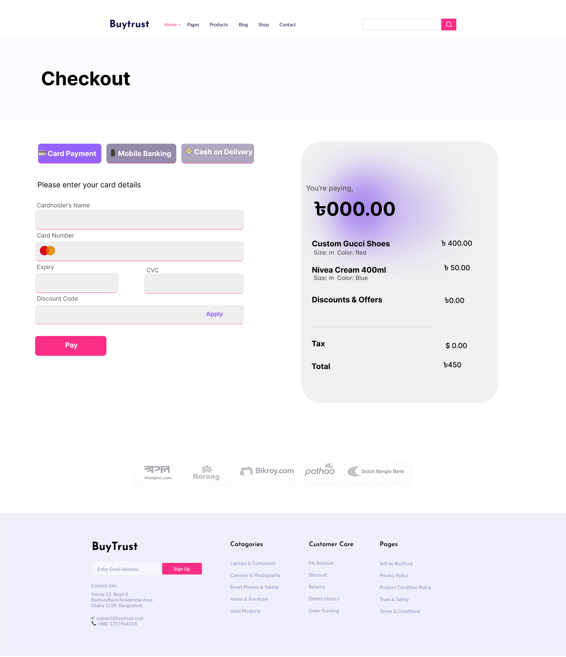

Fig: Checkout Page
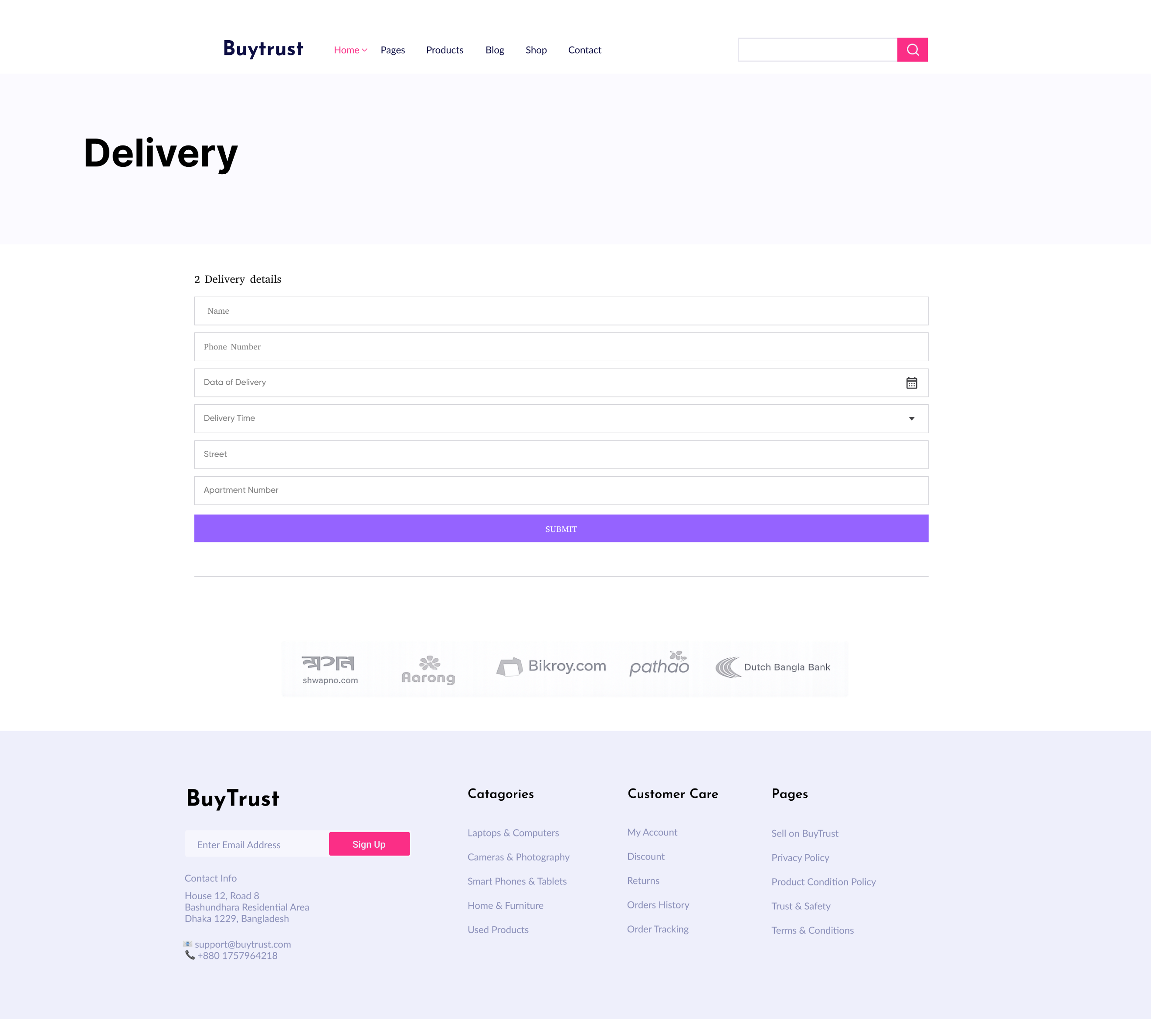

Fig: Delivery Page
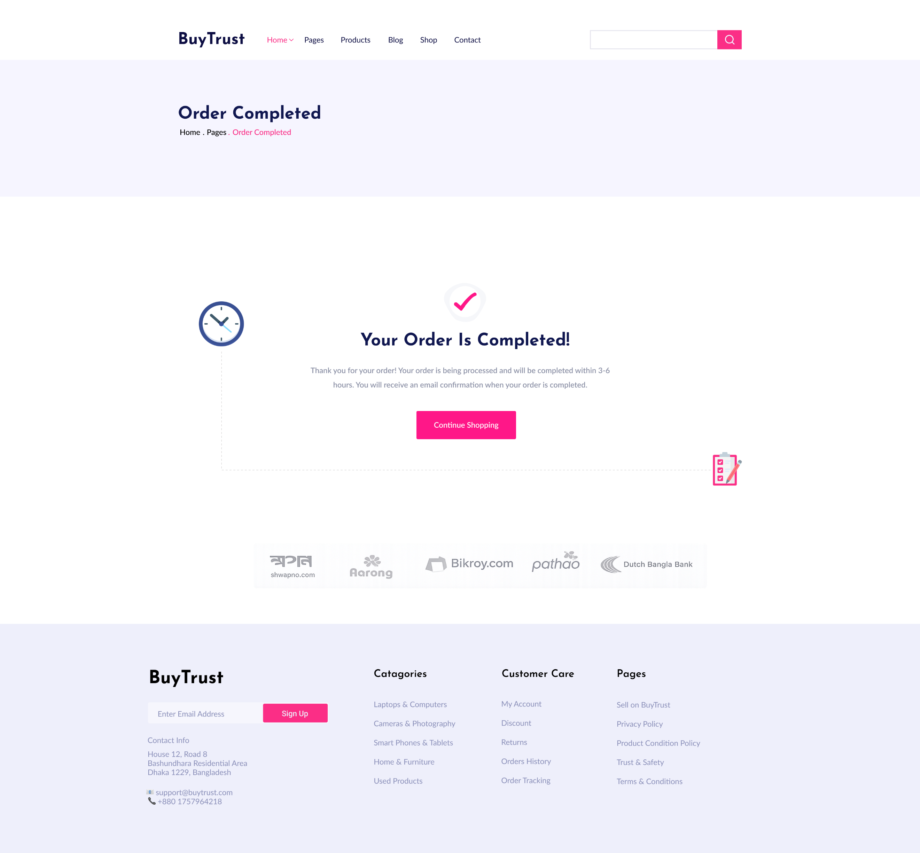
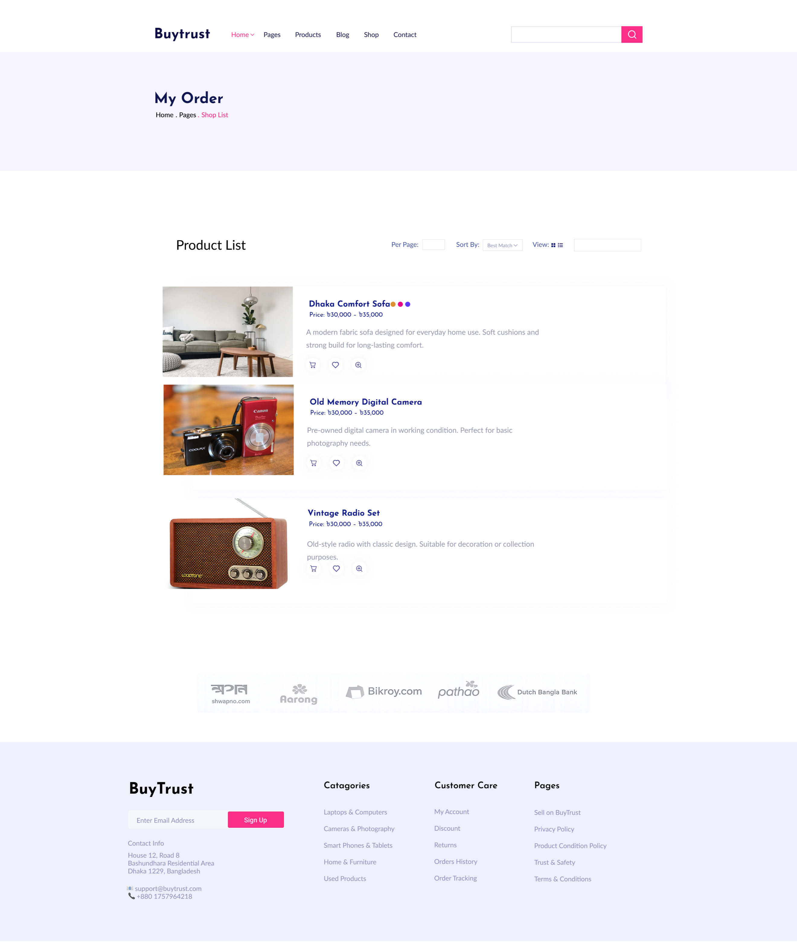
Fig: Order Completed Page

Fig: My Order Page
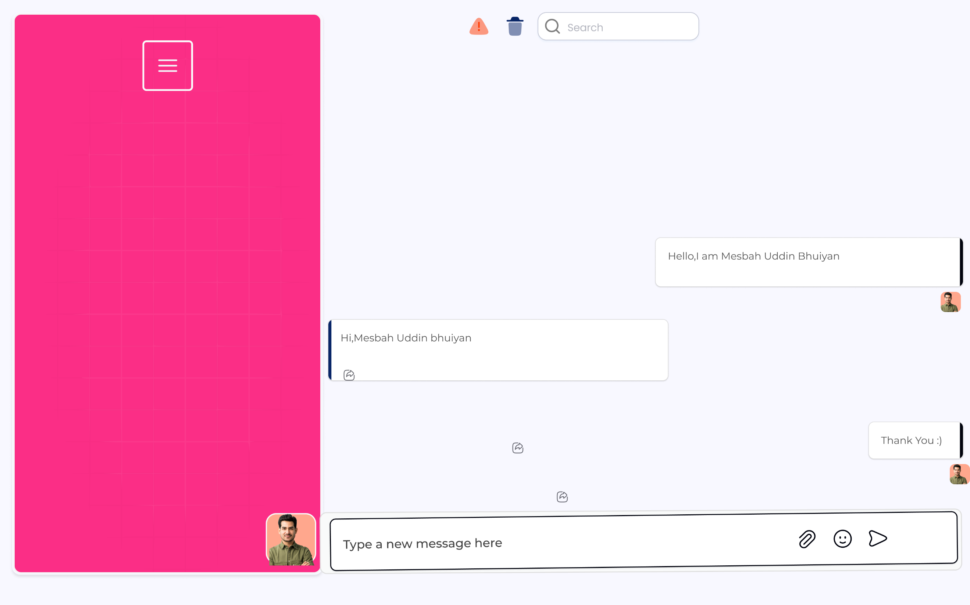
Fig: Chatbot Page\

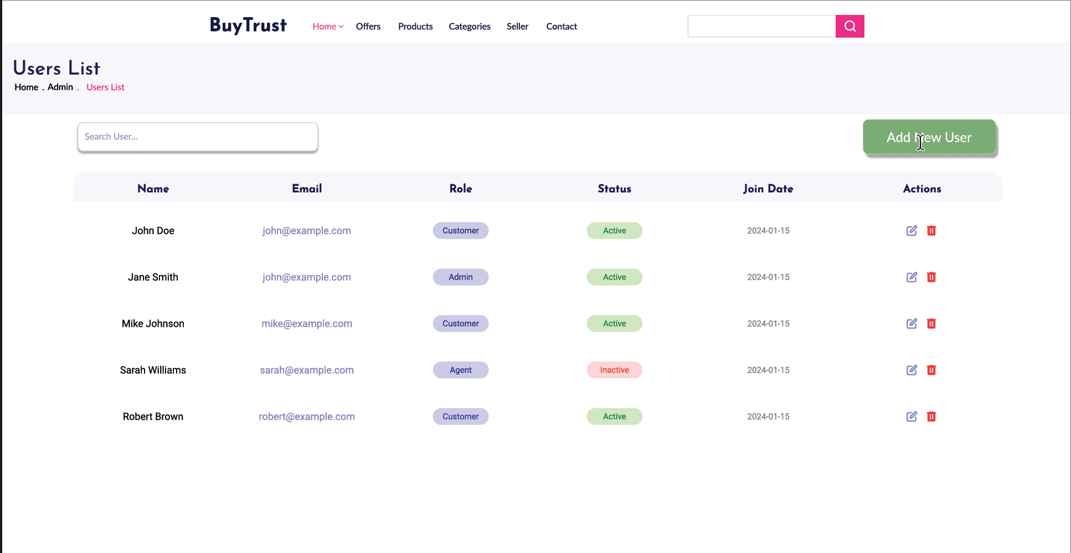
Fig: Users List Page

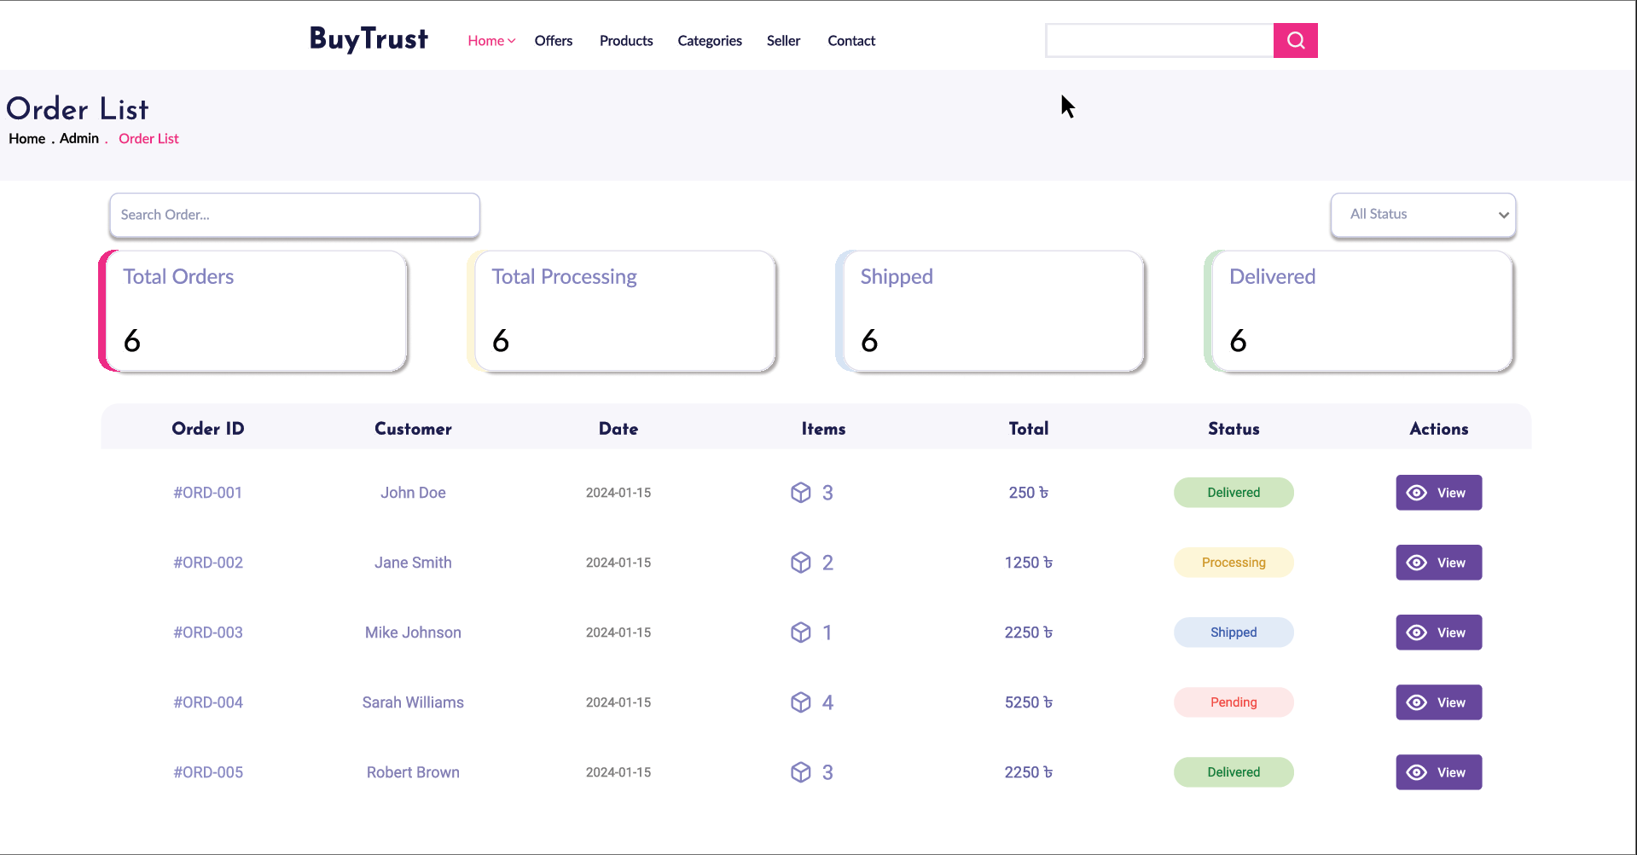

Fig: Order List Page

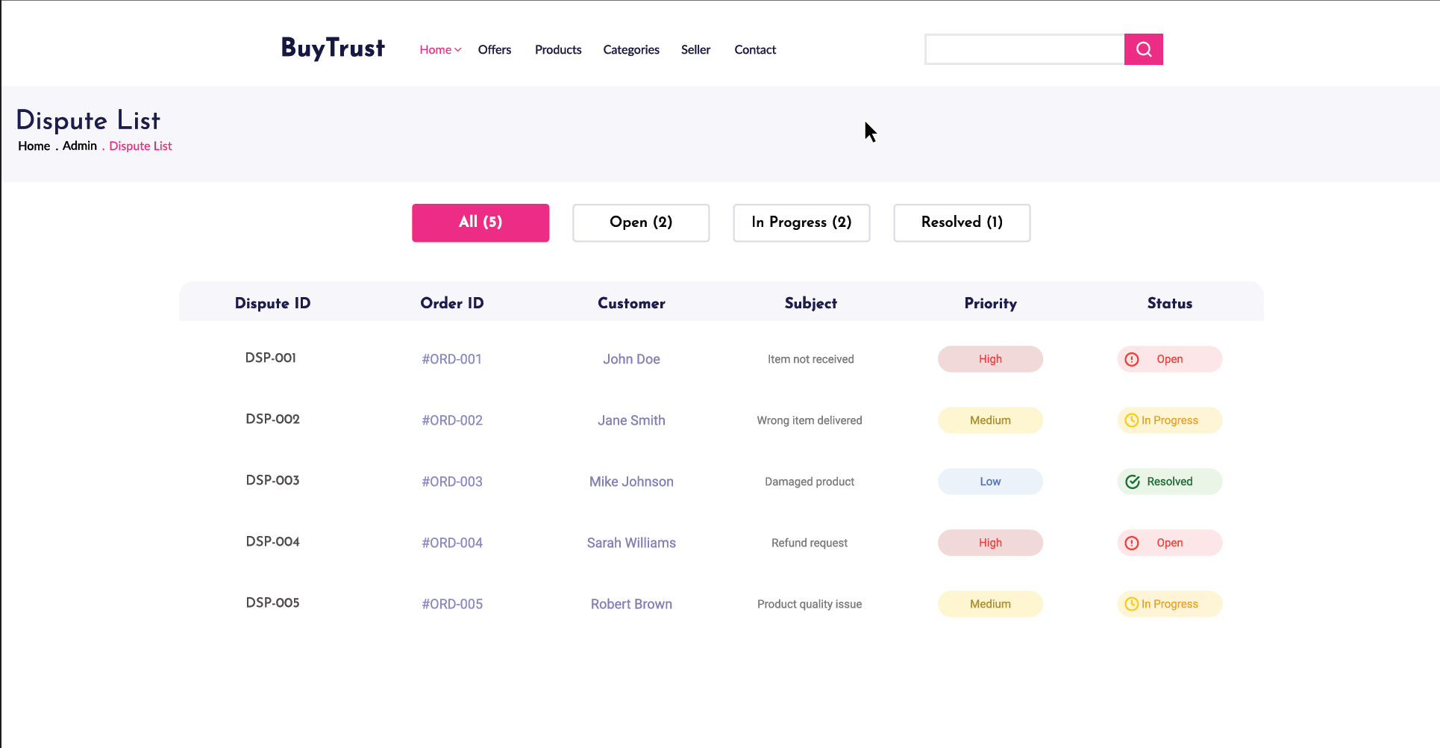
Fig: Dispute Page

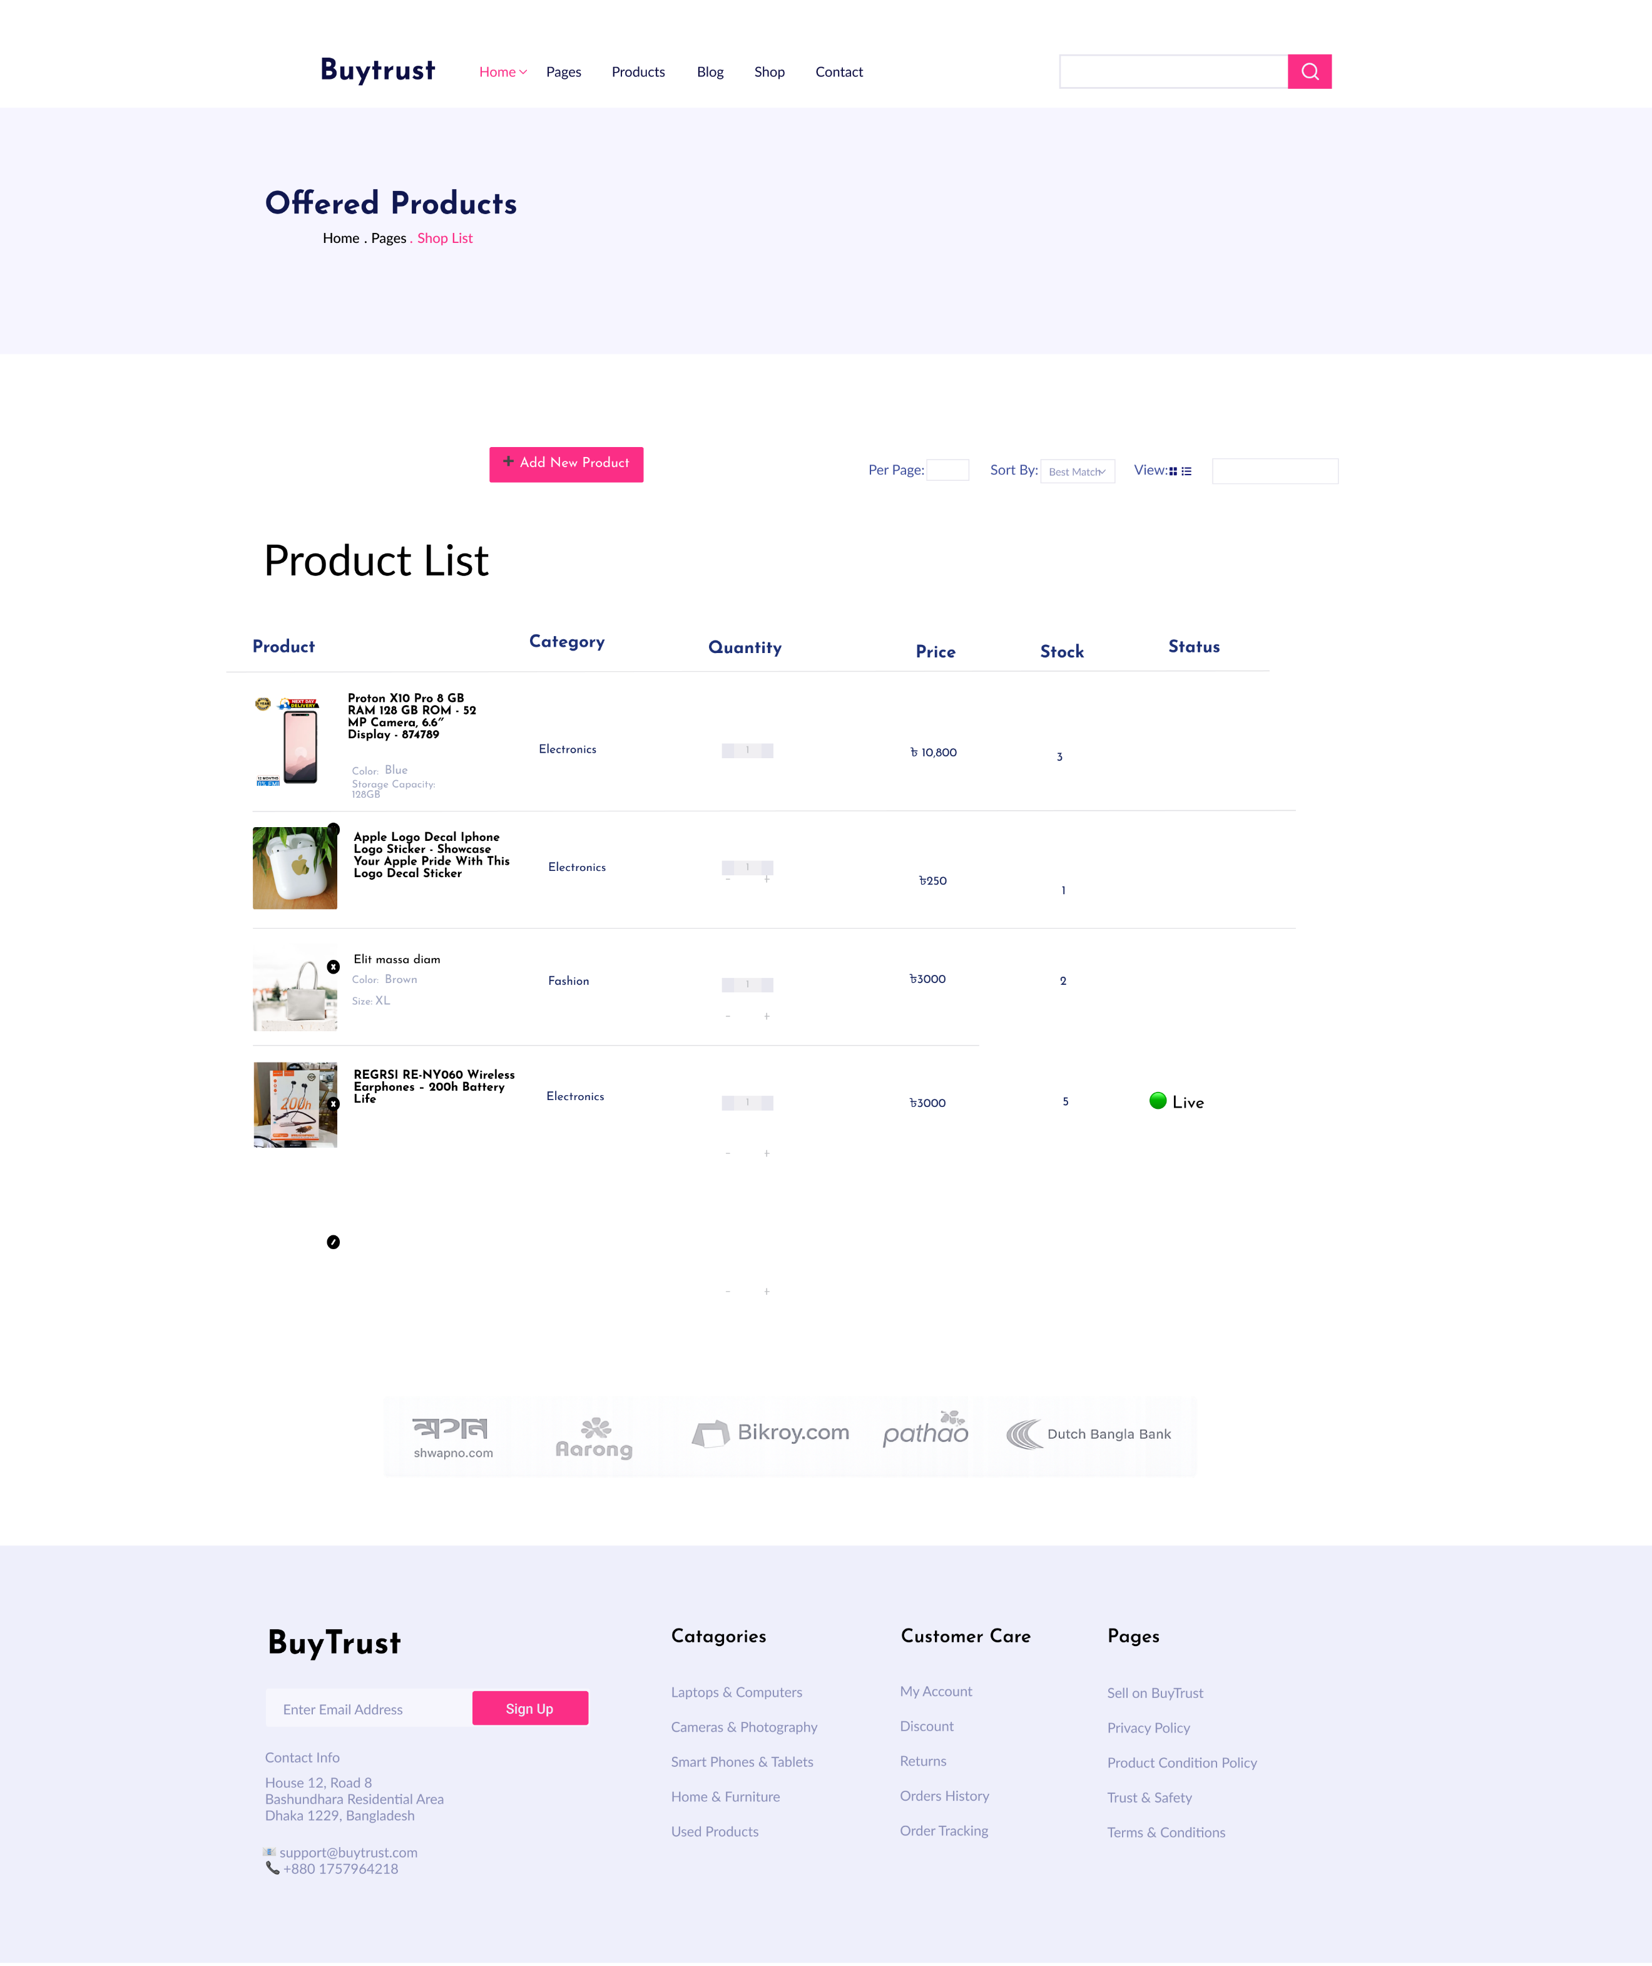
Fig: Offered products Page

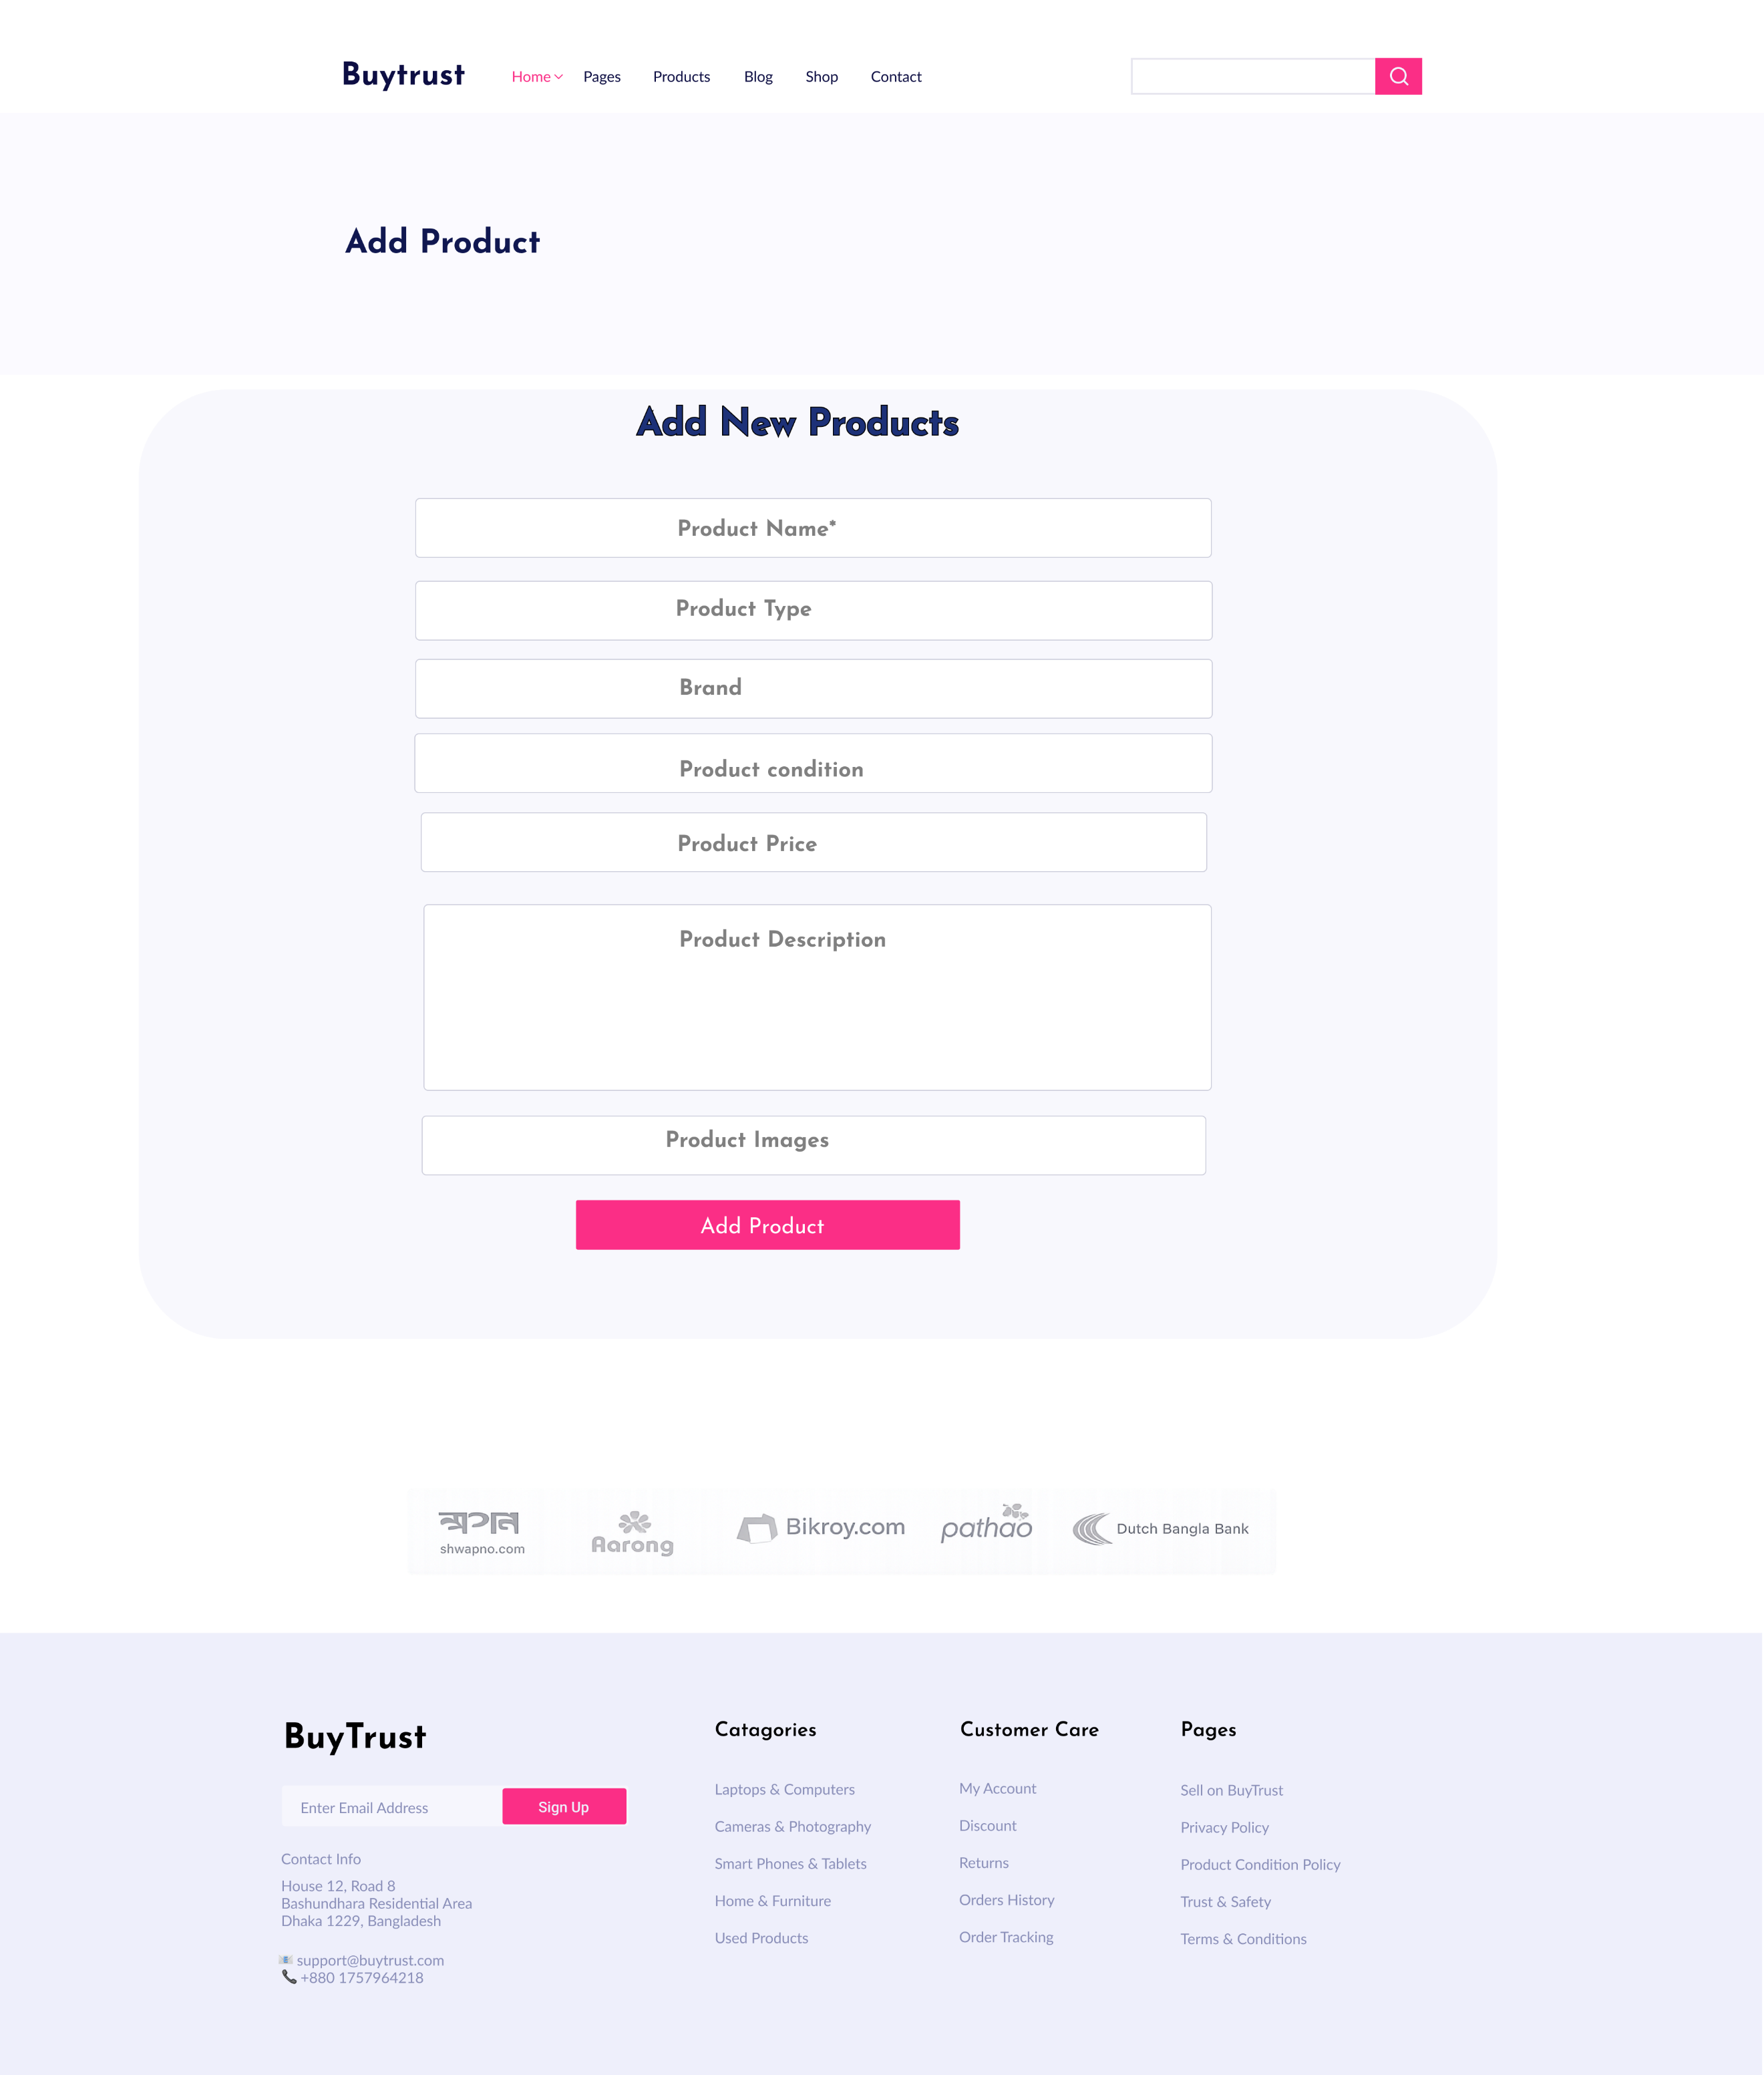

Fig: Add/Update products Page

4. GIT WORKFLOW
- Create a central repository for the project on GitHub and set the master (or main) branch as the primary branch for integration.
- Each member should clone the repository and create their own feature branches for assigned tasks. Work on new features or fixes within these branches.
- Add files, stage them and commit changes with clear messages that describe the purpose of each update.
- Push commits from the feature branches to the remote repository so other members can see progress.
- Use pull to fetch and integrate changes from the remote repository into local copies, ensuring everyone stays updated.
- Merge feature branches into the master/main branch only after the work is tested and reviewed, resolving any conflicts that occur.
- Show evidence of collaboration by maintaining a clear commit history (using logs) with multiple commits, merges and contributions from all group members.
- Keep the repository organized with a clean history that tracks the project workflow from initialization to completion.

5. SOFTWARE TESTING
Project Name: BuyTrust: Your Marketplace for New & Pre-owned Items |  |  | Test Designed by: Md. Joha Mondal
Test Case ID: TC_1 |  |  | Test Designed date: 04/01/2026
Test Priority (Low, Medium, High): High |  |  | Test Executed by:
Module Name: Login Session |  |  | Test Execution date:
Test Title: Verify login with valid username and password
Description: Test the website login page
Precondition: The user has a registered account
Dependencies: Authentication API, Session management, Database
Test Steps | Test Data | Expected Results |  | Actual Results | Status (Pass/Fail)
1. Open Login page (UI)  2. Enter valid email/username  3. Enter password  4. Click Login | Email: murad.t@test.com  Password: Test@1234 | User is authenticated and redirected to dashboard. Session token/cookie set. User name shown on header.

Project Name: BuyTrust: Your Marketplace for New & Pre-owned Items |  |  | Test Designed by: Md. Joha Mondal
Test Case ID: TC_2 |  |  | Test Designed date: 04/01/2026
Test Priority (Low, Medium, High): High |  |  | Test Executed by:
Module Name: User Registration (Signup) |  |  | Test Execution date:
Test Title: Verify registration with valid user information and OTP
Description: Test the signup flow including OTP verification
Precondition: Signup page accessible; OTP service available
Dependencies: Registration API, OTP service, Database
Test Steps | Test Data | Expected Results |  | Actual Results | Status (Pass/Fail)
1. Open Signup page  2. Fill Name, Email, Phone, Password, Confirm Password, select User Type  3. Click Signup  4. Receive OTP and enter it  5. Click Verify | Name: Murad Hasan  Email: murad.t@test.com  Phone: 01710000001  Password: Test@1234 | Form validation passes. OTP received within 30s. After correct OTP, account created and user redirected to dashboard. New user record in DB.

Project Name: BuyTrust: Your Marketplace for New & Pre-owned Items |  |  | Test Designed by: Md. Joha Mondal
Test Case ID: TC_3 |  |  | Test Designed date: 04/01/2026
Test Priority (Low, Medium, High): Medium |  |  | Test Executed by:
Module Name: Forgot Password / Password Recovery |  |  | Test Execution date:
Test Title: Verify password reset via OTP/email
Description: Test forgot password flow and password update
Precondition: User has registered email/phone
Dependencies: OTP/email service, Auth API, Database
Test Steps | Test Data | Expected Results |  | Actual Results | Status (Pass/Fail)
1. Open Login page and click Forgot Password  2. Enter registered email and submit  3. Receive OTP/link, enter OTP or follow link  4. Enter new password and confirm  5. Submit | Email: murad.t@test.com  New Password: NewTest@123 | OTP/link received. After valid OTP/new password, password updated; user can login with new password. Success message shown.

Project Name: BuyTrust: Your Marketplace for New & Pre-owned Items |  |  | Test Designed by: Md. Joha Mondal
Test Case ID: TC_04 |  |  | Test Designed date: 04/01/2026
Test Priority (Low, Medium, High): Medium |  |  | Test Executed by:
Module Name: Profile Management |  |  | Test Execution date:
Test Title: Verify user profile update (name, phone, address, picture
Description: Test editing and saving profile information
Precondition: User is logged in
Dependencies: Profile API, Database, Image upload
Test Steps | Test Data | Expected Results |  | Actual Results | Status (Pass/Fail)
1. Login and open Profile page  2. Change phone/address and upload profile image (<=3MB)  3. Click Save/Update  4. Refresh profile page | Phone: 01710000002  Address: Dhaka, Bangladesh  Image: profile.jpg (2MB) | Profile updates successfully; new data shown immediately; DB updated. Image uploaded and visible. Success message shown.

Project Name: BuyTrust: Your Marketplace for New & Pre-owned Items |  |  | Test Designed by: Md. Joha Mondal
Test Case ID: TC_05 |  |  | Test Designed date: 04/01/2026
Test Priority (Low, Medium, High): High |  |  | Test Executed by:
Module Name: Add Product (Seller) |  |  | Test Execution date:
Test Title: Verify seller can add product with images and valid details
Description: Test add product flow and listing visibility
Precondition: Seller account logged in
Dependencies: Product API, Image upload, Database
Test Steps | Test Data | Expected Results |  | Actual Results | Status (Pass/Fail)
1. Login as seller  2. Go to Add Product page  3. Enter product name, category, price, qty, description  4. Upload images (each ≤ 3MB)  5. Click Add Product  6. Check seller product list and public listing | Name: Used Mobile - Samsung A12  Price: 8000  Quantity: 1  Images: img1.jpg (2MB) | Product saved; success message shown. Product appears in seller listing and searchable on site. DB product record created with image URLs.

Project Name: BuyTrust: Your Marketplace for New & Pre-owned Items |  |  | Test Designed by: Md. Joha Mondal
Test Case ID: TC_06 |  |  | Test Designed date: 04/01/2026
Test Priority (Low, Medium, High): High |  |  | Test Executed by:
Module Name: Edit Product |  |  | Test Execution date:
Test Title: verify seller can edit product details
Description: Test product update functionality
Precondition: Seller is logged in and product exists
Dependencies: Product management API, Database
Test Steps | Test Data | Expected Results |  | Actual Results | Status (Pass/Fail)
1. Login as seller  2. Open product list  3. Click edit on a product  4. Change price/details  5. Click update | New Price: 7500  Description: Updated info | Product information should be updated and saved successfully

Project Name: BuyTrust: Your Marketplace for New & Pre-owned Items |  |  | Test Designed by: Md. Joha Mondal
Test Case ID: TC_07 |  |  | Test Designed date: 04/01/2026
Test Priority (Low, Medium, High): High |  |  | Test Executed by:
Module Name: Delete Product |  |  | Test Execution date:
Test Title: Verify seller can delete a product
Description: Test product deletion functionality
Precondition: Seller is logged in and product exists
Dependencies: Product management API, Database
Test Steps | Test Data | Expected Results |  | Actual Results | Status (Pass/Fail)
1. Login as seller  2. Open product list  3. Click delete  4. Confirm deletion | Product ID: P102 | Product should be removed from seller list and public view

Project Name: BuyTrust: Your Marketplace for New & Pre-owned Items |  |  | Test Designed by: Md. Joha Mondal
Test Case ID: TC_08 |  |  | Test Designed date: 04/01/2026
Test Priority (Low, Medium, High): Medium |  |  | Test Executed by:
Module Name: Browse Products |  |  | Test Execution date:
Test Title: Verify buyer can view product listing
Description: Test product browsing on homepage
Precondition: Products exist in the system
Dependencies: Product listing service
Test Steps | Test Data | Expected Results |  | Actual Results | Status (Pass/Fail)
1. Open homepage  2. Scroll product list | Product ID: P102 | Products should be displayed with image, name, and price

Project Name: BuyTrust: Your Marketplace for New & Pre-owned Items |  |  | Test Designed by: Md. Joha Mondal
Test Case ID: TC_09 |  |  | Test Designed date: 04/01/2026
Test Priority (Low, Medium, High): Medium |  |  | Test Executed by:
Module Name: Product Details |  |  | Test Execution date:
Test Title: Verify product details page information
Description: Test product details view
Precondition: Product exists
Dependencies: Product details API
Test Steps | Test Data | Expected Results |  | Actual Results | Status (Pass/Fail)
1. Click on a product  2. Open product details page | Product ID: P102 | Full product information should be displayed correctly

Project Name: BuyTrust: Your Marketplace for New & Pre-owned Items |  |  | Test Designed by: Md. Joha Mondal
Test Case ID: TC_10 |  |  | Test Designed date: 04/01/2026
Test Priority (Low, Medium, High): Medium |  |  | Test Executed by:
Module Name: Product Search |  |  | Test Execution date:
Test Title: Verify product search using keyword
Description: Test search functionality
Precondition: Products exist in the system
Dependencies: Search service
Test Steps | Test Data | Expected Results |  | Actual Results | Status (Pass/Fail)
1. Enter keyword in search box  2. Click search | Keyword: Samsung | Matching products should be shown in search results

Project Name: BuyTrust: Your Marketplace for New & Pre-owned Items |  |  | Test Designed by: Md. Joha Mondal
Test Case ID: TC_11 |  |  | Test Designed date: 04/01/2026
Test Priority (Low, Medium, High): High |  |  | Test Executed by:
Module Name: Add to Cart |  |  | Test Execution date:
Test Title: Verify add product to cart and quantity update
Description: Test adding product to cart and updating quantity
Precondition: Buyer logged in; product in stock
Dependencies: Cart API, Product inventory service
Test Steps | Test Data | Expected Results |  | Actual Results | Status (Pass/Fail)
1. Login as buyer  2. Open product details page  3. Click Add to Cart  4. Go to Cart page  5. Increase quantity to 2 | Product ID: P102  Price: 8000  Initial qty: 1 → Updated qty: 2 | Item appears in cart. Quantity updates correctly. Subtotal recalculates (8000×2). Stock reserved/updated accordingly.

Project Name: BuyTrust: Your Marketplace for New & Pre-owned Items |  |  | Test Designed by: Md. Joha Mondal
Test Case ID: TC_12 |  |  | Test Designed date: 04/01/2026
Test Priority (Low, Medium, High): Medium |  |  | Test Executed by:
Module Name: Remove from Cart |  |  | Test Execution date:
Test Title: Verify remove product from cart and cart update
Description: Test removing item from cart and cart recalculation
Precondition: Buyer has at least one item in cart
Dependencies: Cart API, Session
Test Steps | Test Data | Expected Results |  | Actual Results | Status (Pass/Fail)
1. Login as buyer  2. Open Cart page  3. Click Remove/Delete on an item  4. Confirm deletion | Product ID: P102 (in cart) | Item removed from cart. Cart item count and subtotal update. If cart empty, show "Your cart is empty"

Project Name: BuyTrust: Your Marketplace for New & Pre-owned Items |  |  | Test Designed by: Md. Joha Mondal
Test Case ID: TC_13 |  |  | Test Designed date: 04/01/2026
Test Priority (Low, Medium, High): High |  |  | Test Executed by:
Module Name: Checkout / Order Placement |  |  | Test Execution date:
Test Title: Verify checkout calculation (subtotal, 10% commission) and order creation
Description: Test checkout flow including commission and order record
Precondition: Buyer logged in; cart has items; shipping address present
Dependencies: Order service, Payment stub, Commission logic (10%), Database
Test Steps | Test Data | Expected Results |  | Actual Results | Status (Pass/Fail)
1. Open Cart and click Checkout  2. Enter/confirm shipping address  3. Choose payment method (test mode)  4. Review order summary (shows commission)  5. Click Place Order | Items: 2 × 8000 = 16000  Commission: 10% (1600)  Shipping: 50 | Order summary shows Subtotal=16000, Commission=1600, Shipping=50, Total=17650. On successful payment stub, order record created with status Pending (or Confirmed) and order ID returned. Buyer redirected to order confirmation page.

Project Name: BuyTrust: Your Marketplace for New & Pre-owned Items |  |  | Test Designed by: Md. Joha Mondal
Test Case ID: TC_14 |  |  | Test Designed date: 04/01/2026
Test Priority (Low, Medium, High): High |  |  | Test Executed by:
Module Name: Payment Processing |  |  | Test Execution date:
Test Title: Verify secure payment processing (success & failure scenarios)
Description: Test payment gateway integration (success and failure handling)
Precondition: Checkout initiated and payment gateway reachable (test/sandbox)
Dependencies: Payment gateway (sandbox), Order API, Transaction logging
Test Steps | Test Data | Expected Results |  | Actual Results | Status (Pass/Fail)
1. From Checkout, select card/mobile payment in sandbox  2. Enter valid test payment details  3. Click Pay (simulate success)  4. Repeat with invalid details (simulate failure) | Card test success / Card test fail | Success: Payment accepted, transaction reference shown, order status updates to Paid/Confirmed, notifications sent. Failure: Payment rejected, user shown error, order not created or marked Payment Failed, retry option available.

Project Name: BuyTrust: Your Marketplace for New & Pre-owned Items |  |  | Test Designed by: Md. Joha Mondal
Test Case ID: TC_14 |  |  | Test Designed date: 04/01/2026
Test Priority (Low, Medium, High): High |  |  | Test Executed by:
Module Name: Payment Processing |  |  | Test Execution date:
Test Title: Verify secure payment processing (success & failure scenarios)
Description: Test payment gateway integration (success and failure handling)
Precondition: Checkout initiated and payment gateway reachable (test/sandbox)
Dependencies: Payment gateway (sandbox), Order API, Transaction logging
Test Steps | Test Data | Expected Results |  | Actual Results | Status (Pass/Fail)
1. From Checkout, select card/mobile payment in sandbox  2. Enter valid test payment details  3. Click Pay (simulate success)  4. Repeat with invalid details (simulate failure) | Card test success / Card test fail | Success: Payment accepted, transaction reference shown, order status updates to Paid/Confirmed, notifications sent. Failure: Payment rejected, user shown error, order not created or marked Payment Failed, retry option available.

Project Name: BuyTrust: Your Marketplace for New & Pre-owned Items |  |  | Test Designed by: Md. Joha Mondal
Test Case ID: TC_15 |  |  | Test Designed date: 04/01/2026
Test Priority (Low, Medium, High): Medium |  |  | Test Executed by:
Module Name: Delivery Status / Order Tracking |  |  | Test Execution date:
Test Title: Verify delivery status updates and tracking visibility
Description: Test order status transitions and buyer visibility of delivery info
Precondition: Order created and assigned to delivery team
Dependencies: Delivery service, Order status API, Notifications
Test Steps | Test Data | Expected Results |  | Actual Results | Status (Pass/Fail)
1. As admin/delivery staff, update order status to Out for Delivery  2. Update to Delivered after completion  3. Buyer opens order tracking page | Order ID: ORD_1001 | Status changes reflected in buyer view within acceptable delay. Delivery person name/contact visible to buyer. Notifications sent on status change. Final status Delivered shown with timestamp.

6. CONCLUSION
- Write a conclusion within 180 to 200 words.

Instructions:
- Minimum of 3 members and Maximum of 5 members per group.
- Font: Times New Roman ; Size: 12; Justify the para [Ctrl + J].
- Delete the highlighted part after completing this project report.
- The completed report should be within the range of 40 to 50 pages.

- Submission: Bring a hard copy of this report [per group] on the project evaluation day. Also, you will need to upload the soft copy later.

